Data mining and Data integration in Biomedicine

Introduction

Explanatory Data Analysis (EDA)

Data visualization

Unsupervised Learning (I) 🡪 PCA (clustering)

Unsupervised Learning (II)

Supervised Learning (I) 🡪 basic of Machine Learning

Supervised Learning (II)

Introduction To Agentic AI

Core capabilities of AI agents

Python-lab: building an AI agent (practical session of building an agent)

Nonparametric regression model and linear & mixed-effects models

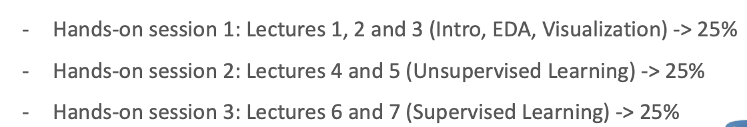

UMAP, t-SNE, PCA…

Decision tree, ML, ….

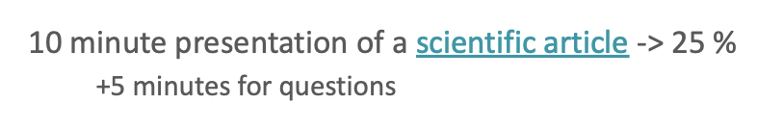

For every task, we will be pairs and randomly assigned. The R projects can be used in jupyternotebook. We can also use Google Colab, but better jupyternotebook.

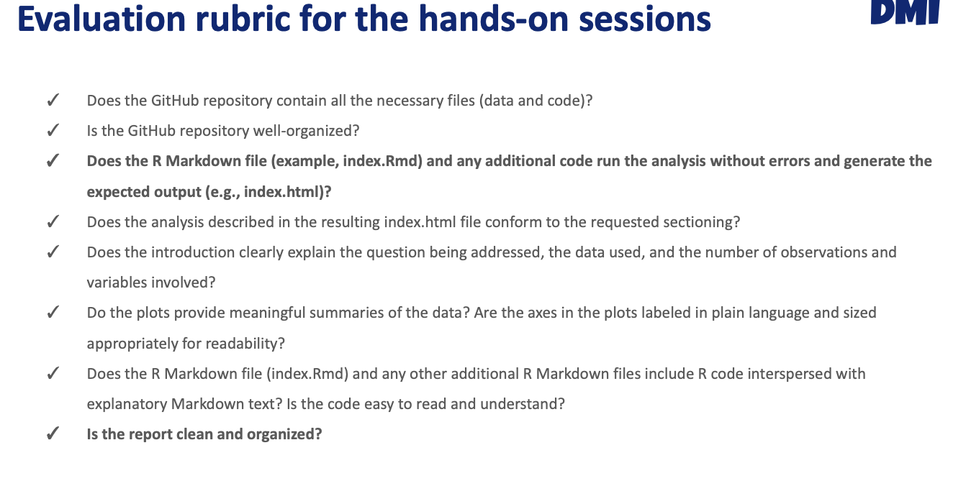

If we print all the data, we will get penalized!

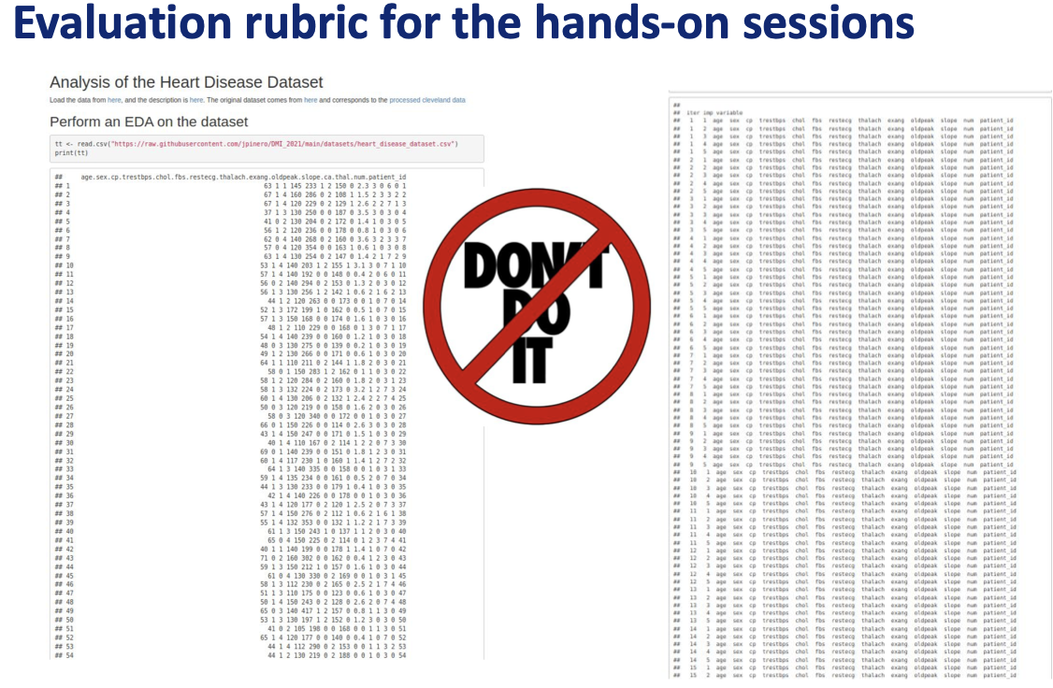

As for the presentation:

Disease vs non-disease, survival or not, etc

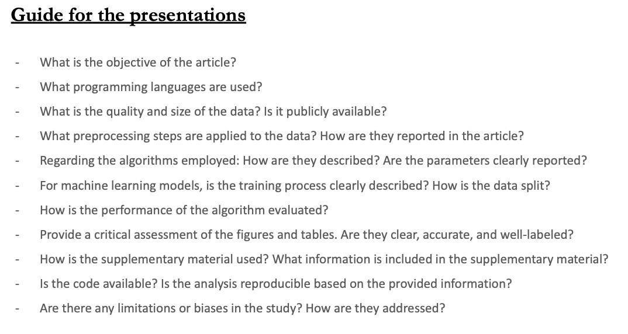

Important to know for future paper writing

# Introduction

Data mining is the science of extracting useful knowledge from huge data repositories. Consists on the extraction of interesting (non-trivial, implicit, previously unknown and potentially useful) patterns or knowledge from huge amount of data.

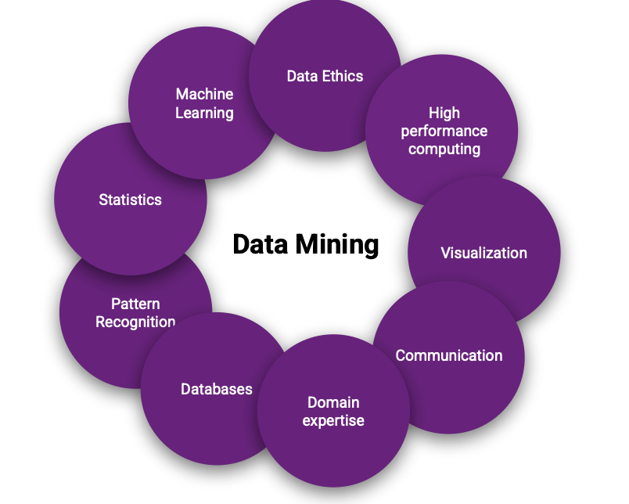Wy is so complicated to analyze some datasets?

* Tremendous amount of data
* High dimensionality of data
  + More features compared to samples/observations
* High complexity and heterogeneity of data

## General steps of the data mining process

1. Define the goal
2. Obtain the data
3. Explanatory data analysis 🡪 takes more time and effort
4. Statistical prediction/modeling
5. Interpret results
6. Synthesize/write up results
7. Create reproducible code

We can start with raw data:

* Binary files
* Unformatted excel file
* JSON data 🡪 text-based data format following JavaScript object syntax

NEVER USE VALUES IN COLUMN NAMES!! JUST ATTRIBUTES

NEVER PUT INFORMATIONC TWO PIECES OF INFORMATION IN THE SAME CELL

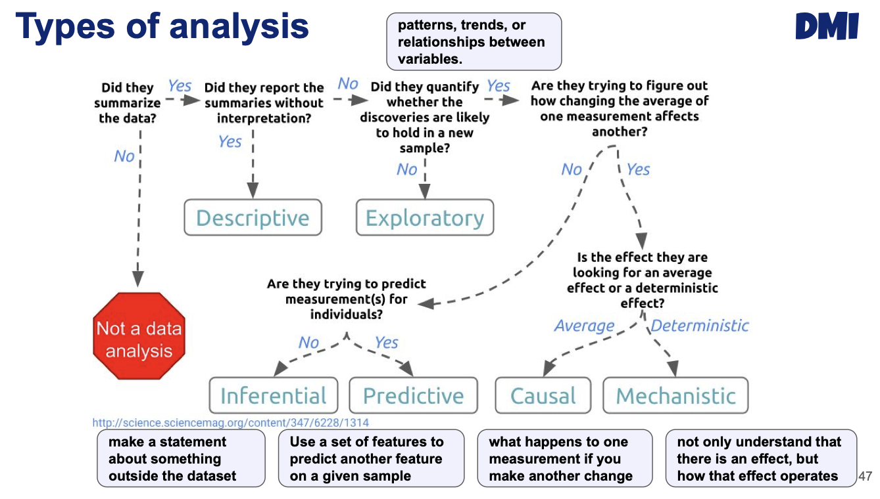

# Explanatory Data Analysis (EDA)

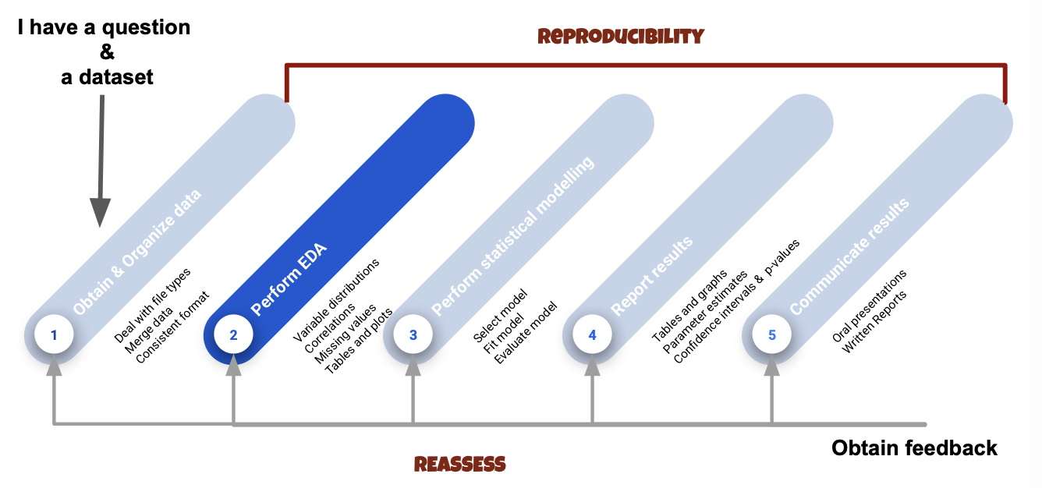

## What is exploratory data analysis (EDA)

* Use methods and graphical tools
* Explore data for patterns, trends, underlying structure, deviations from the trend, anomalies and strange structure
* Preliminary exploration of the data to better understand its characteristics.
* It facilities discovering unexpected as well as conforming the expected

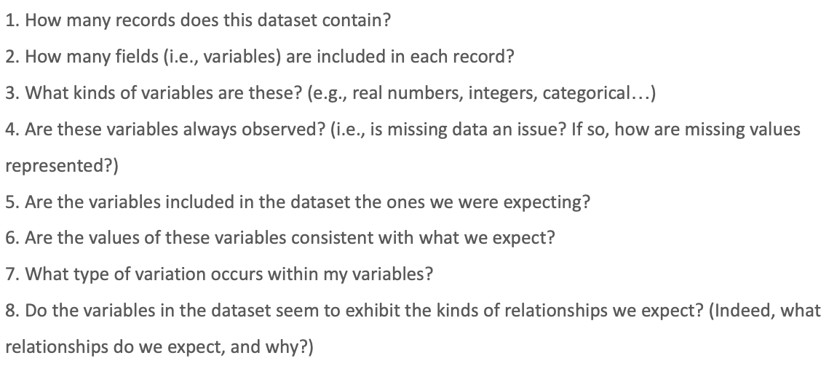



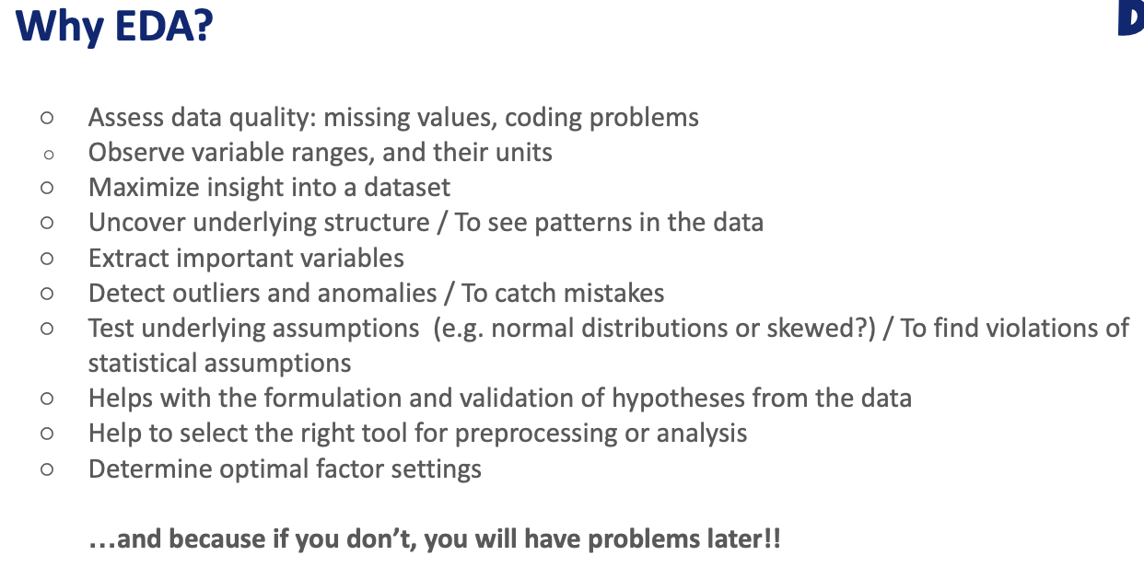



## General steps for an EDA

This are the basic step to cary on the first hands-on-session. The data is from covid patients and do exploratory data analysis.

We will have patients and different attributes that have been done to the patients.

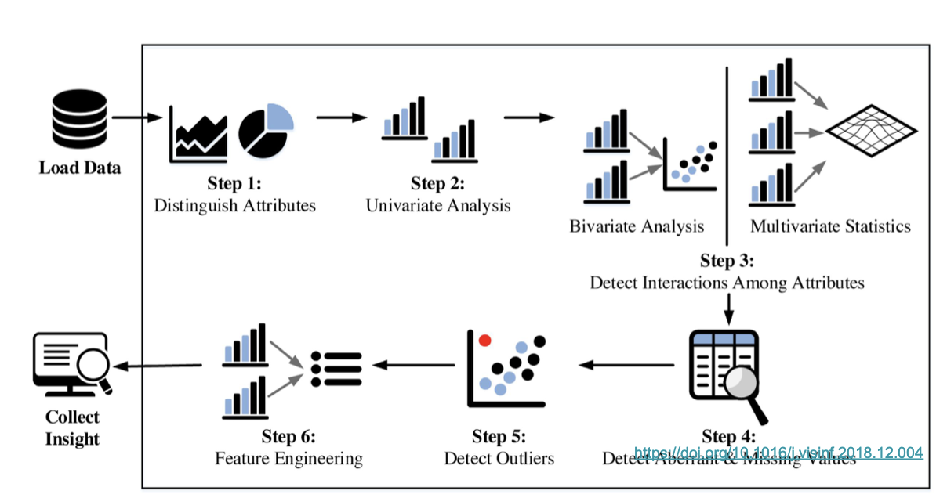

Univariate analysis is going one by one, and detect If there are outliers more later on.

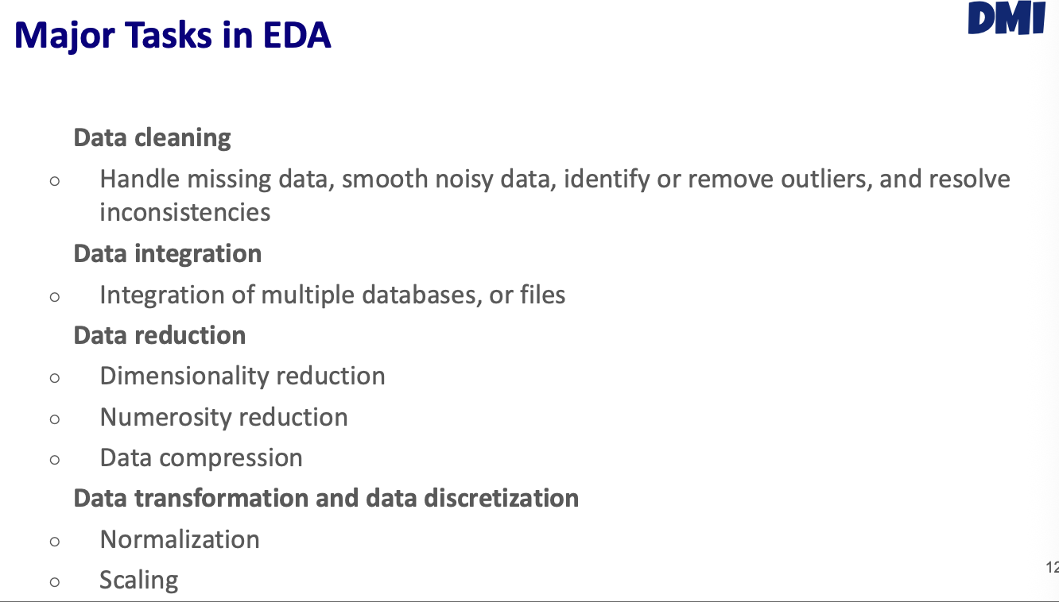

Maybe some proteins is not informative, perhaps is missing or less than the cutoff, or something that does not change a ot beteeen the samples (treatment vs control). Data compression is pCA



Metadata + proteomics information



### Data cleaning

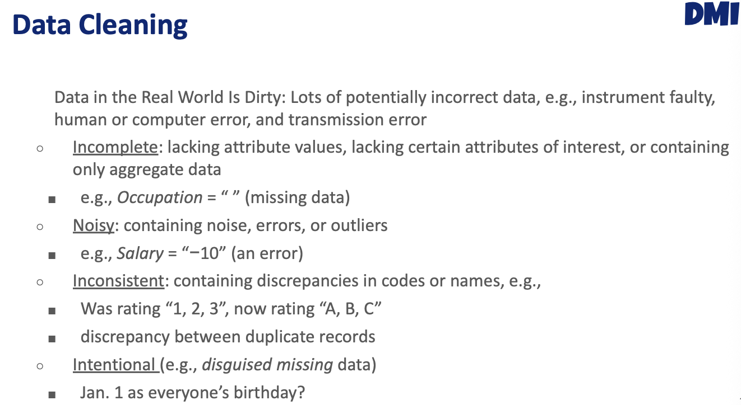

### missing data

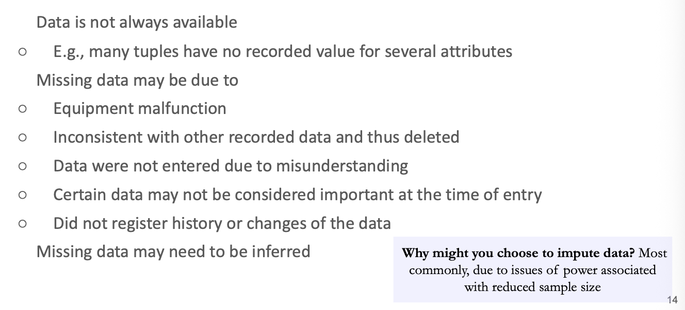

One thing we can do for missing data, would be removing (either attributes or the whole patient).

#### Types of missingness

* Data completely at random 🡪 just randomly missing
* Missing at random 🡪 some value is missing because some value in my data, the missing data depends on other value (recollecting the salaries and age, and young people do not want to report the income, so missing data of the income variable depends on age).
* Missing not at random 🡪 the worse one. For instance, in the salary example, imagine that people that have higer income, do not want to report the income. So missing data is the variables measured.

#### missing values in R

Missing values in R are called:

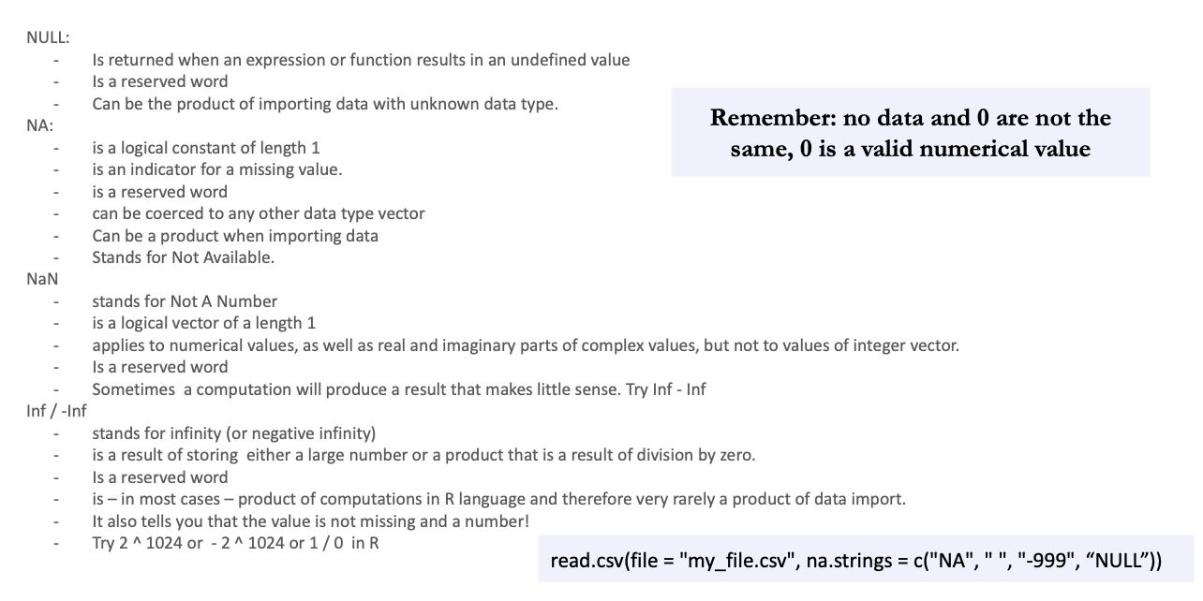

NA is the most important

#### How to handle missing data

What is the methods the researchers used to input the data?

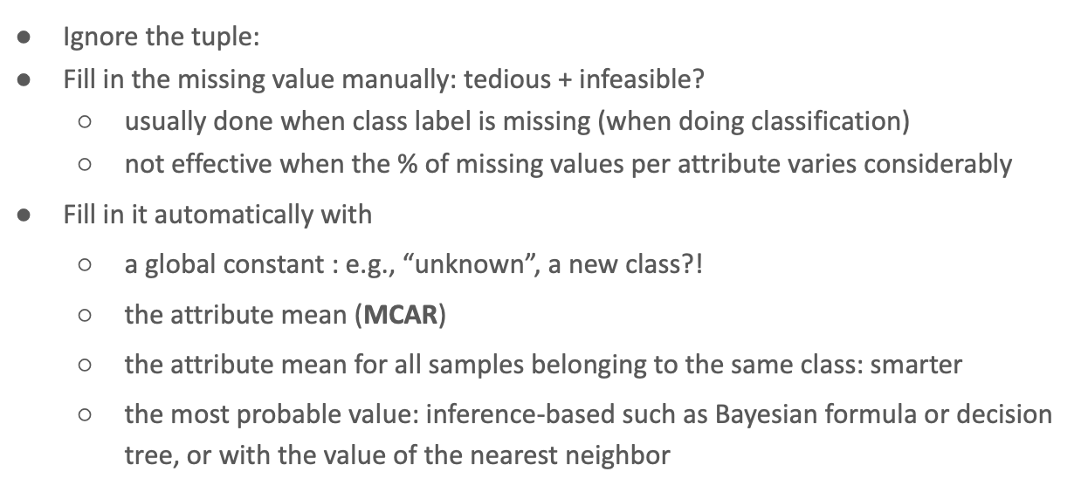



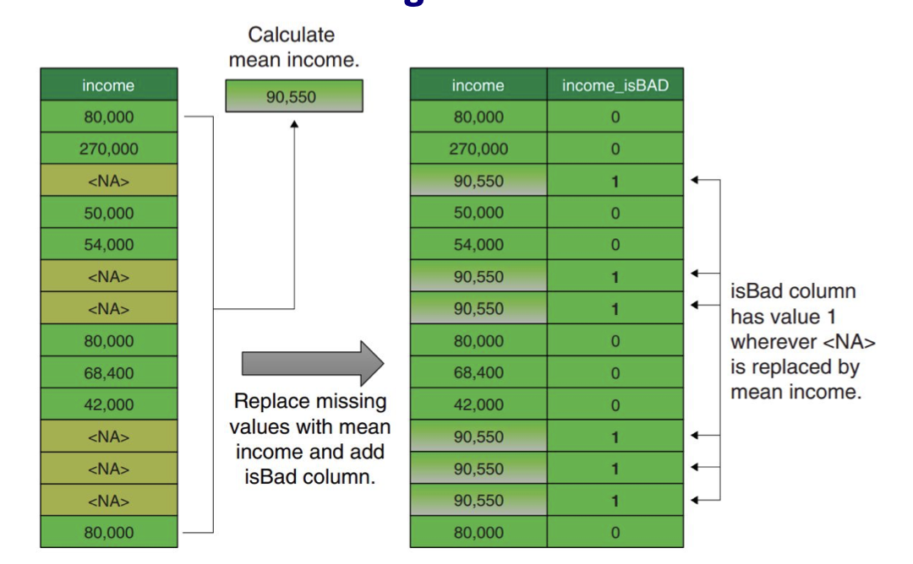

Have a column to keep track that the data have been inputed and not come from the original data.

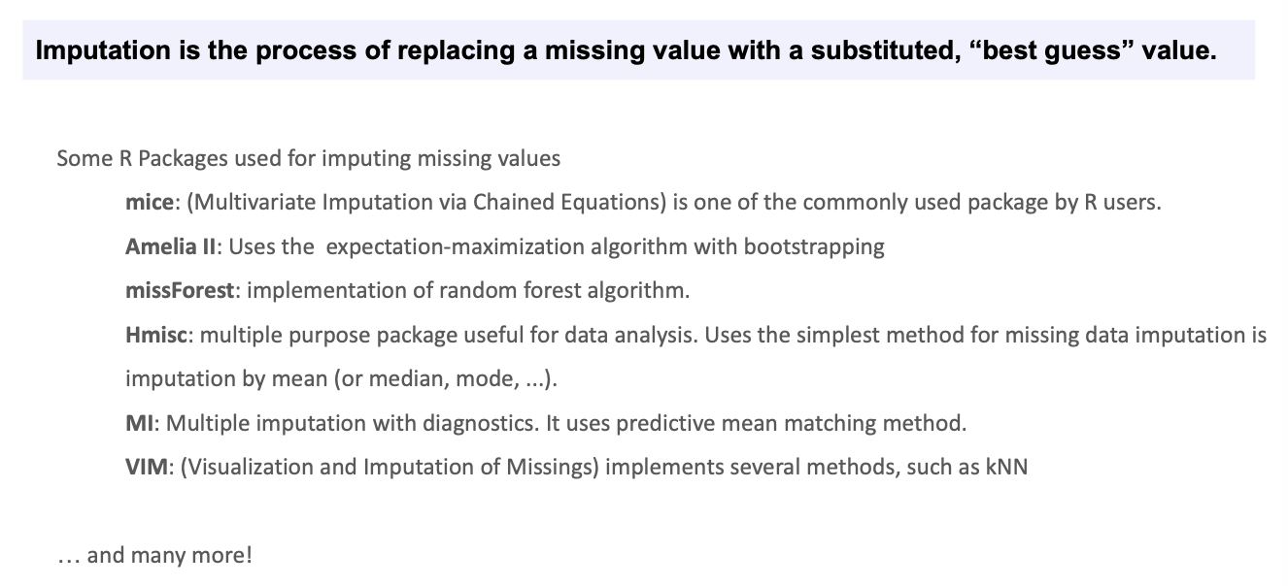



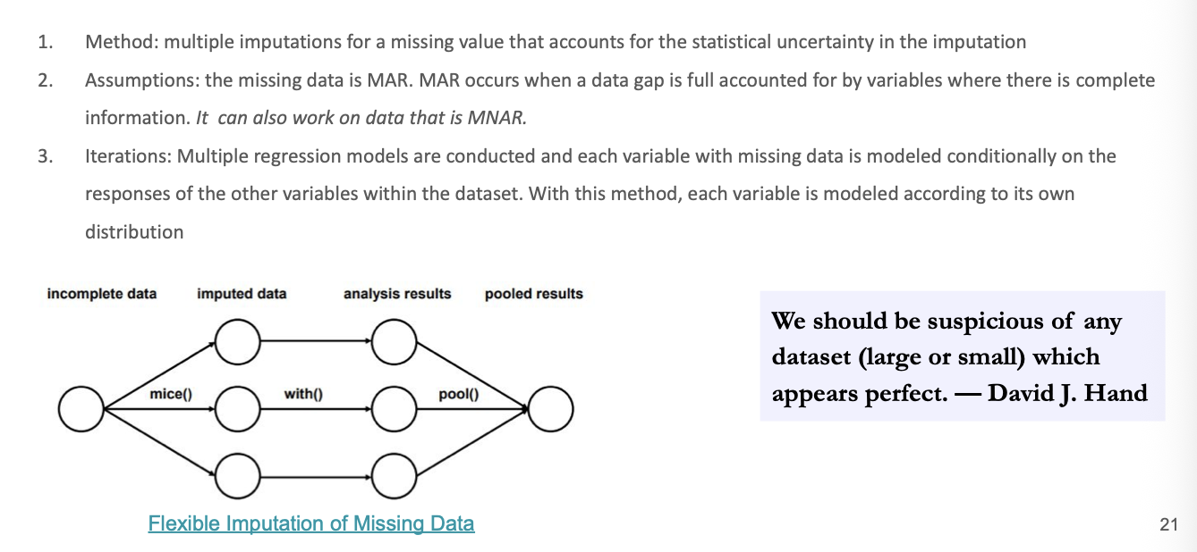

We can use the mean if we do not have much time or the **mice** package, to generate several samples. The mice package to input data and how many data you want to imput.

### Predictive mean matching

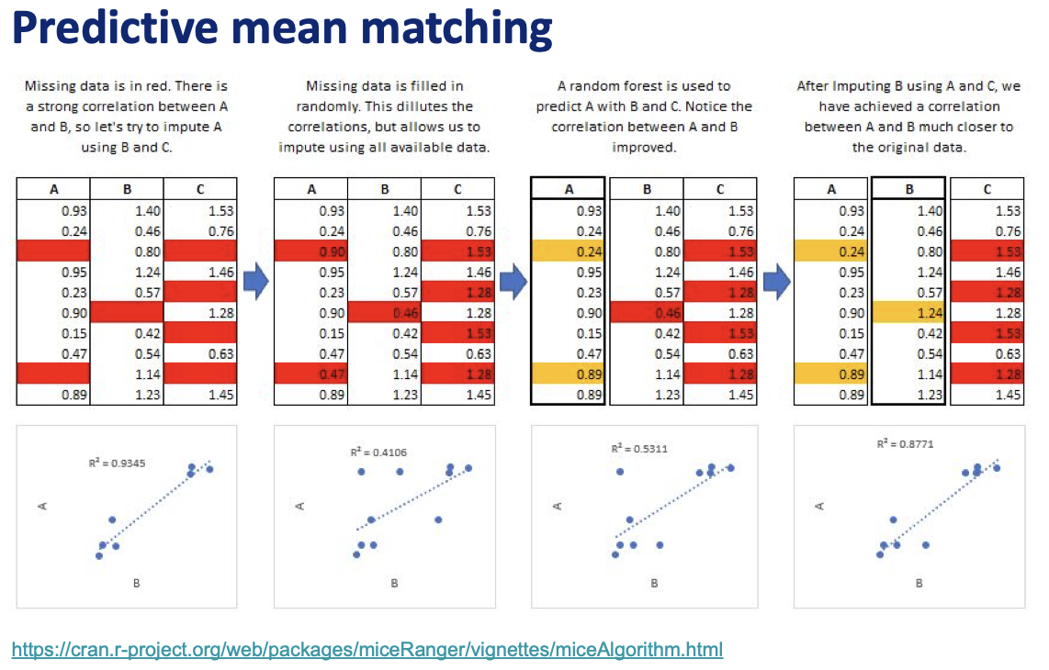

When putting random values, the correlation decreases, so by correcting with a sophisticated model to impute the data would be the best choice. The higher the correlation the better.

It will use ML methods. First builds the model with the data that is not missing and makes a prediction based on this information (like random forest, KNN, etc) and is able to predict the variable, but they don’t take the predicted value, only take the closest value.

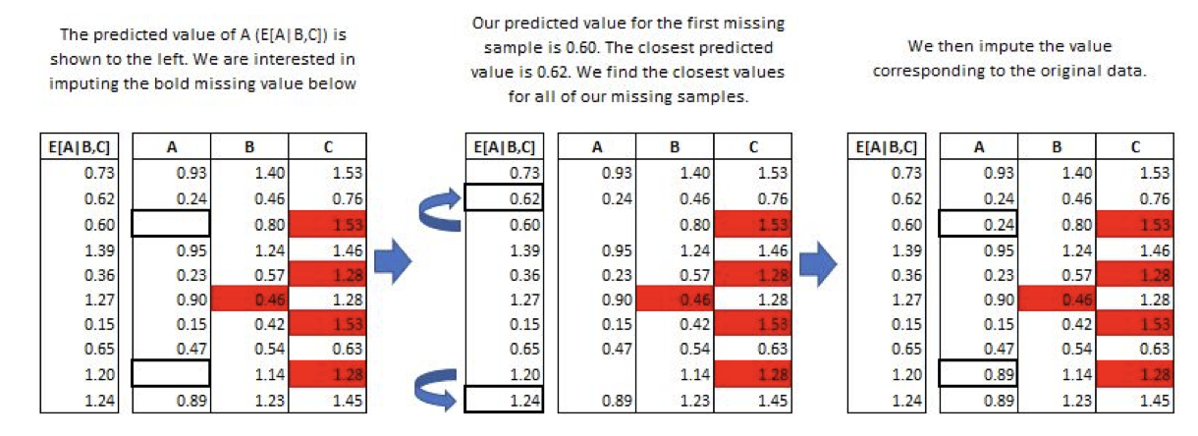

So we are taking values for the real values, we are not inventing. This is another advantage of predicting mean.

### Outliers

Once have the complete dataset, the next thing is to detect outliers. Is something that deviates a lot from the data. Outliers are also referred to as abnormalities, discordants, deviants, or anomalies in the data mining and statistics literature.

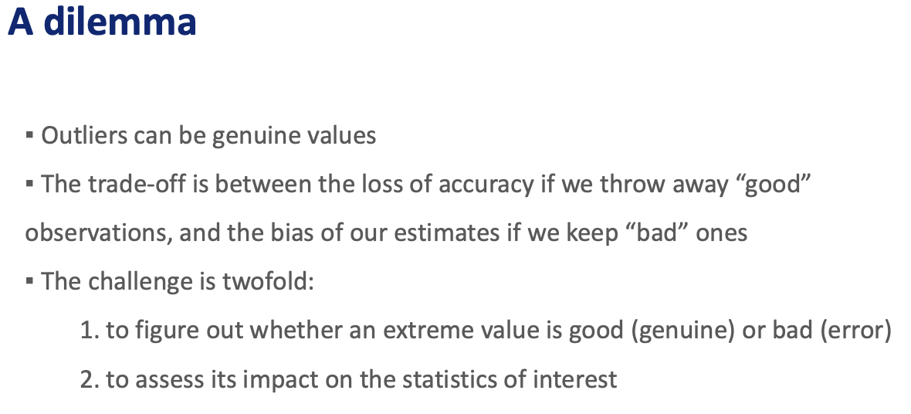

To detect outliers 🡪 boxplot

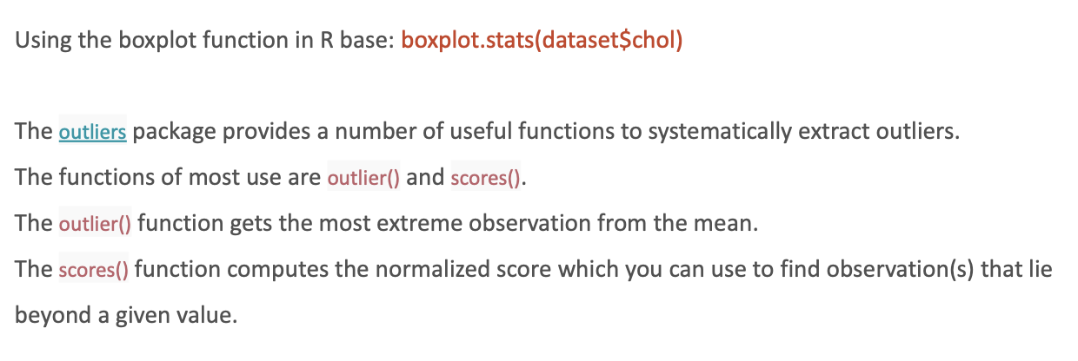



Deleting outliers or replace its value with the maximum value of the boxplot (capping)

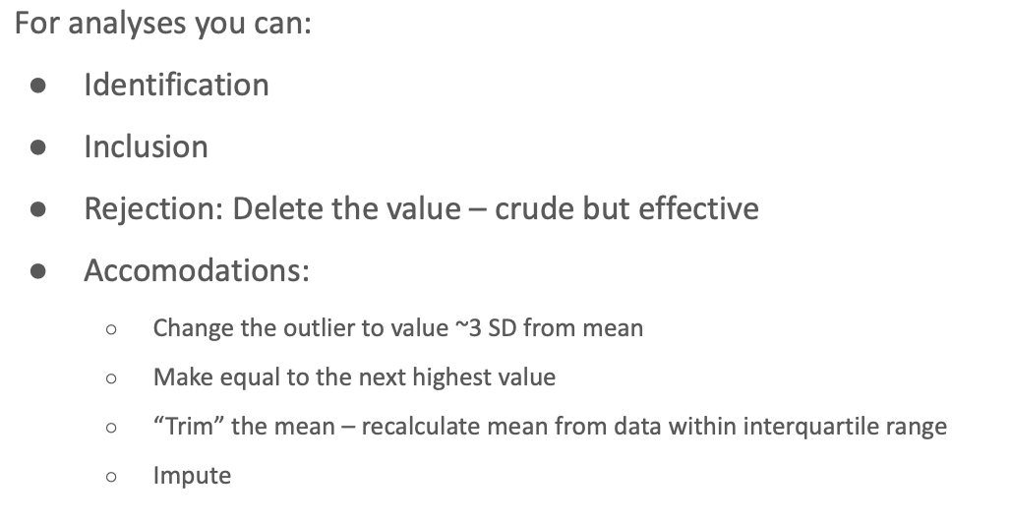

## Methods for exploring Single Variables

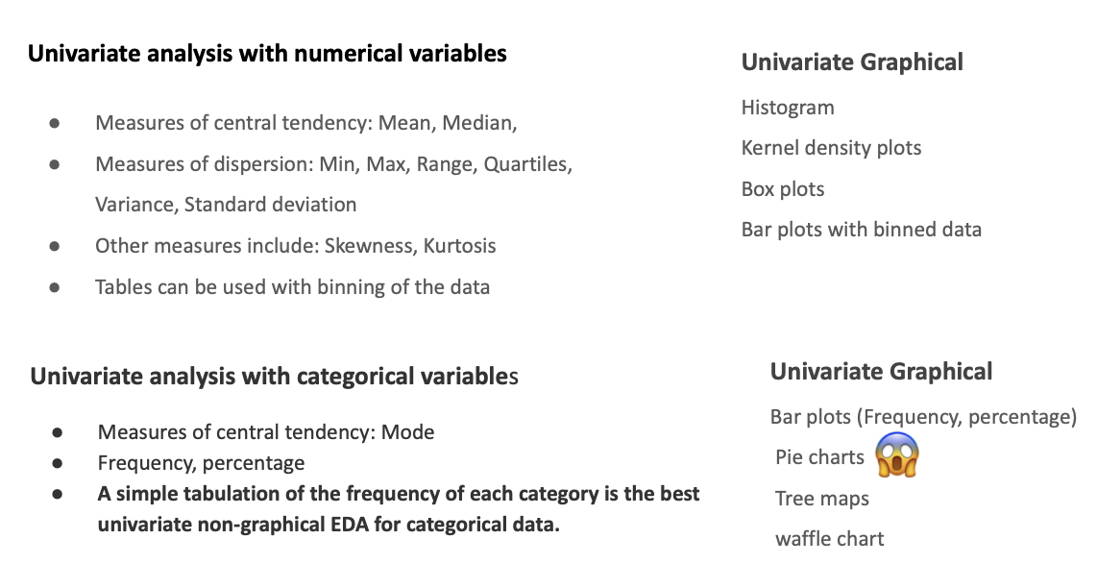



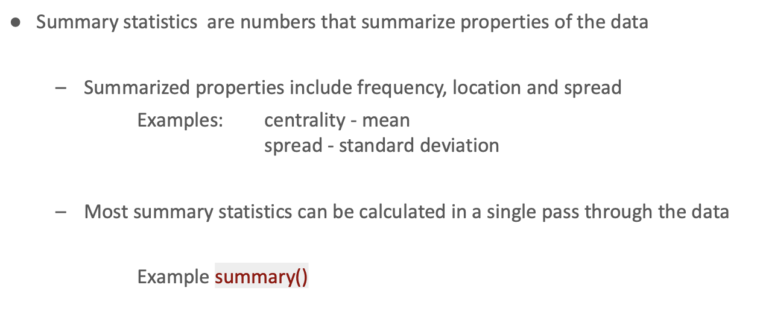

Doing summary()of the whole datasets will give you valuable information

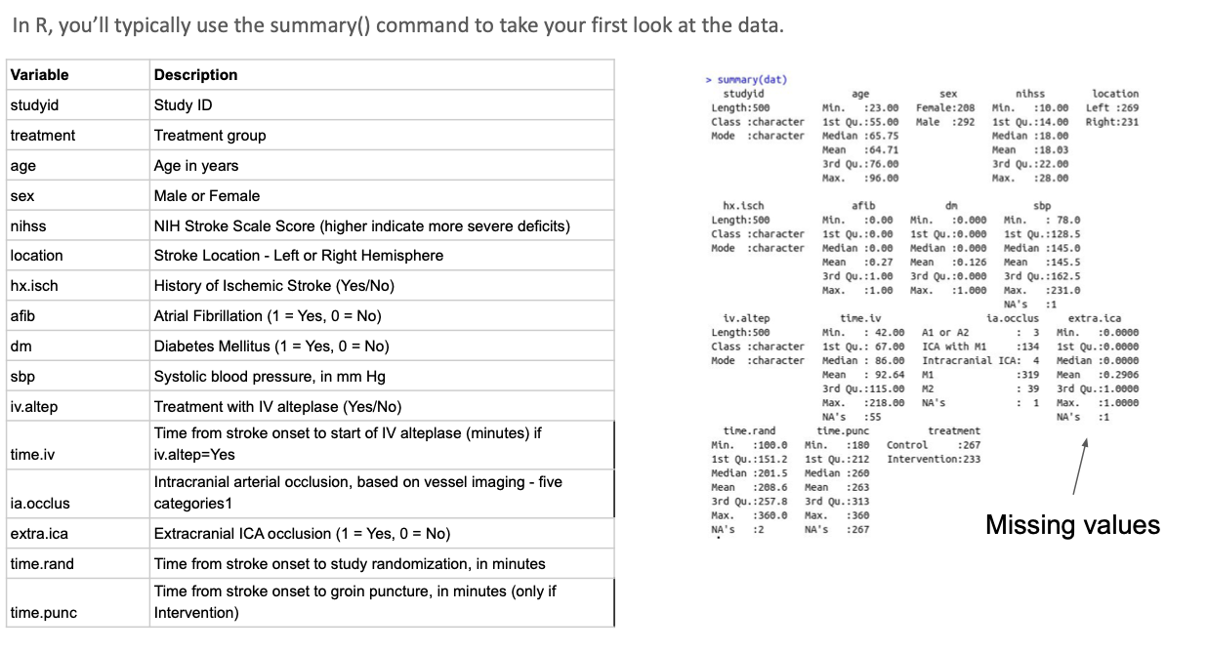

#### Graphical display

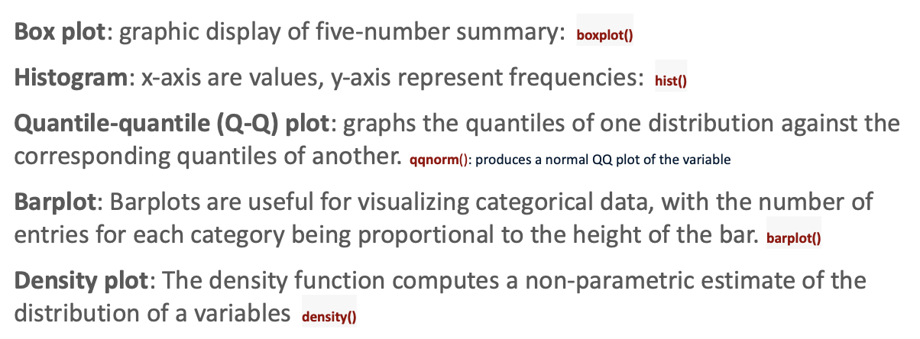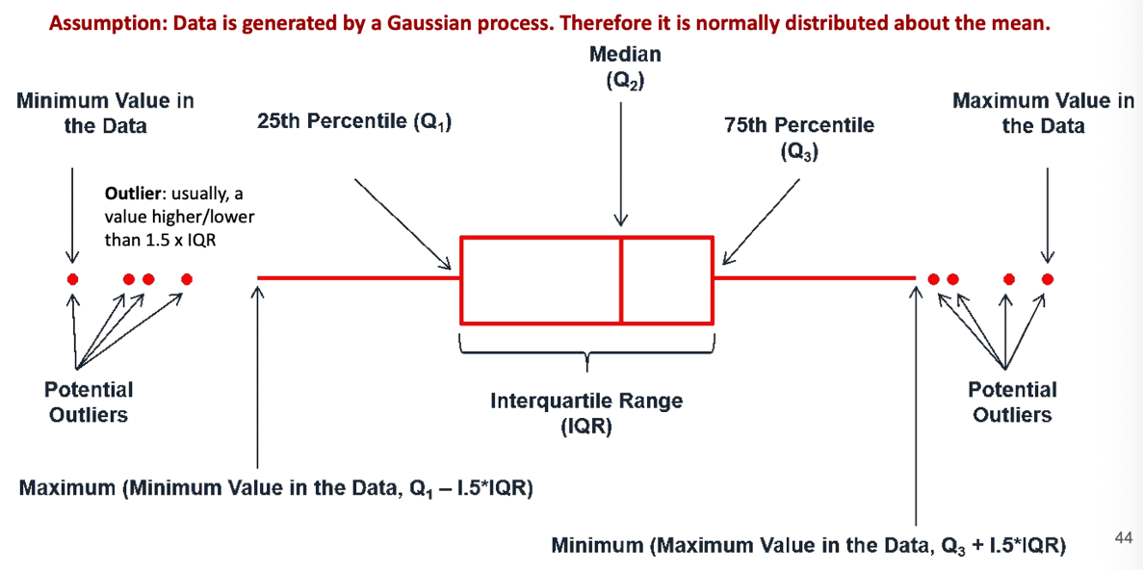

Using density plots after the smoothing we can have values not real, below 0

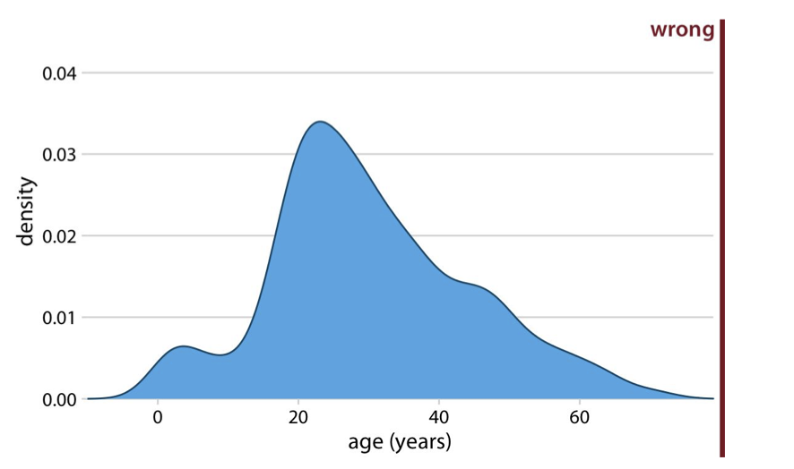

Q-Q plots is to check if our data is normally distributed.

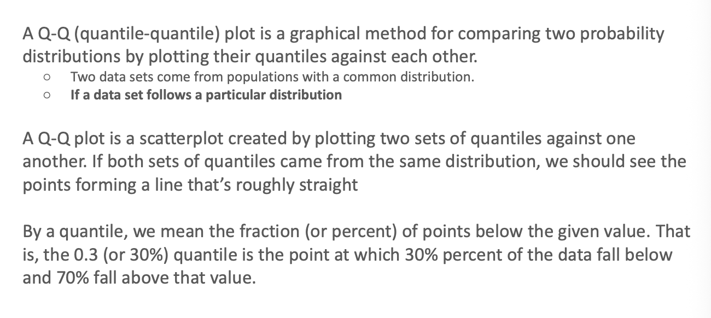

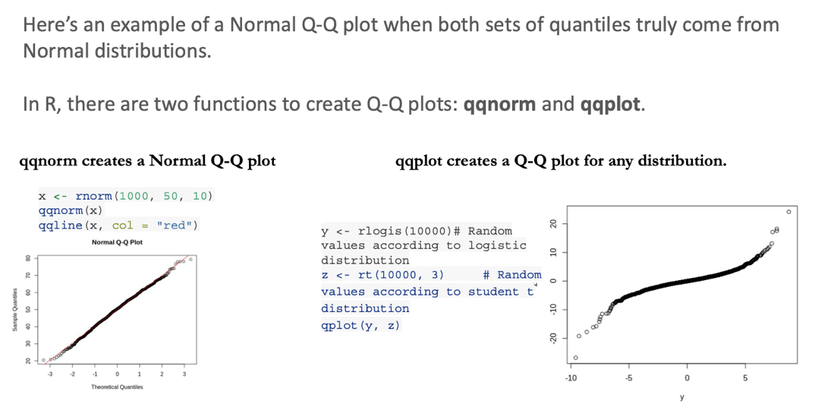

This is normal distributed

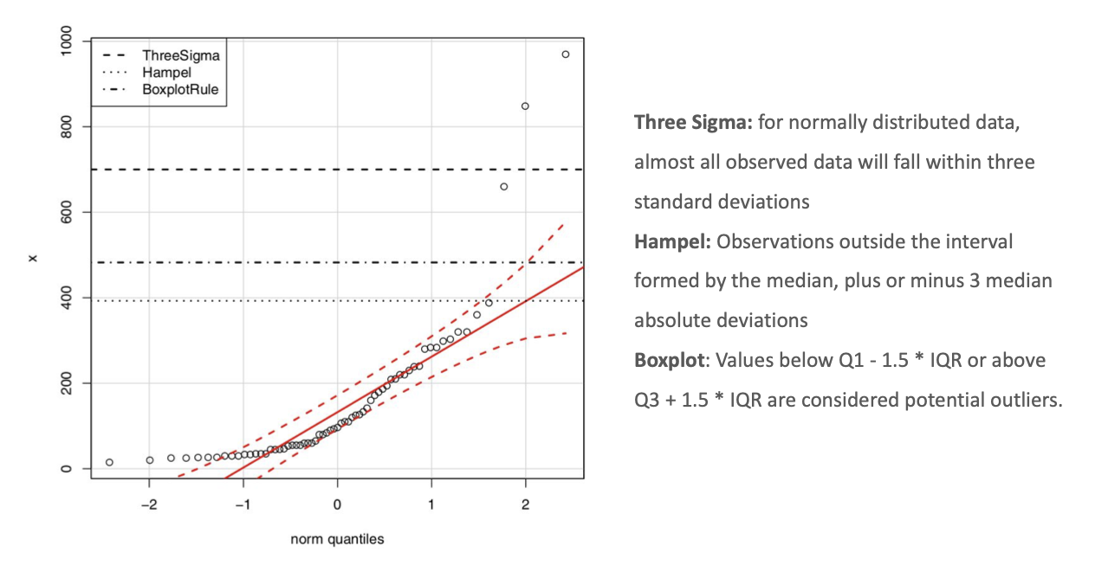

outliers

For categorial data we do tables

## Methods for exploring Relationships Between Two Variables

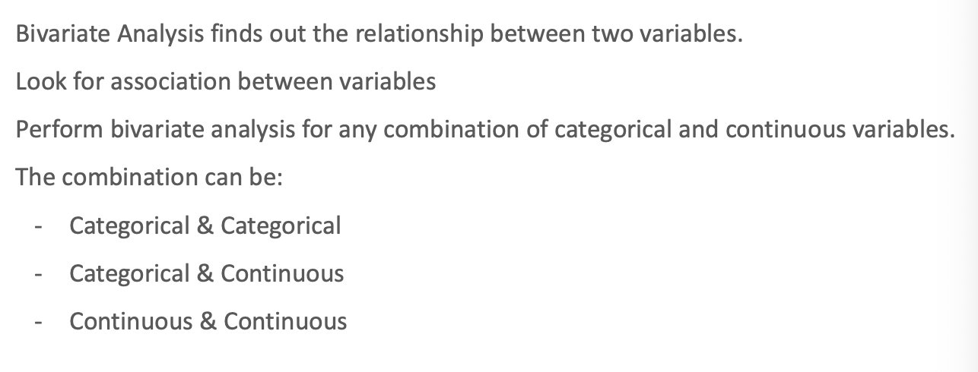

#### categorical & categorical

Only contingency tables

#### continuous & contoiuous

Scatter plot

#### continuous &categorical

Box plots , ggplots, histograms

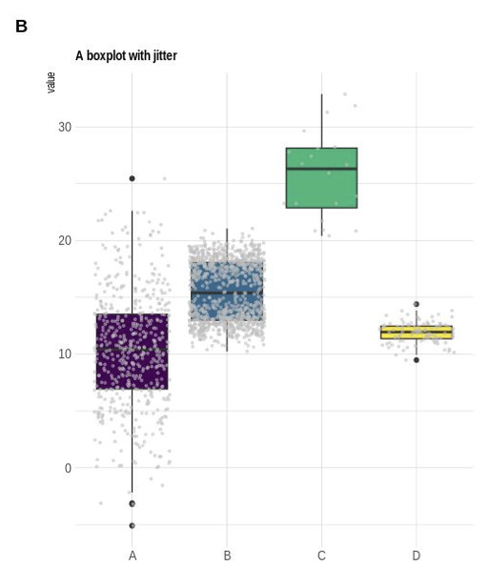Box plot is only distributed in A and B, so show the distribution of the dots as well.

## How to explore More Than Two Variables

Use mlbench package 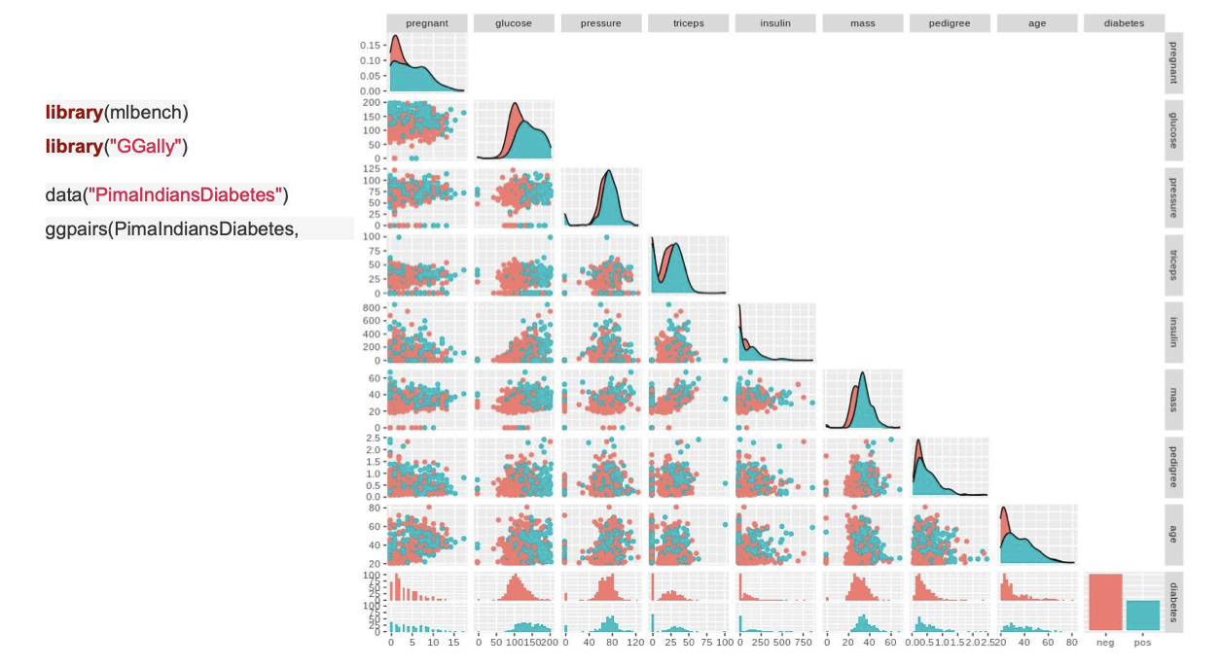

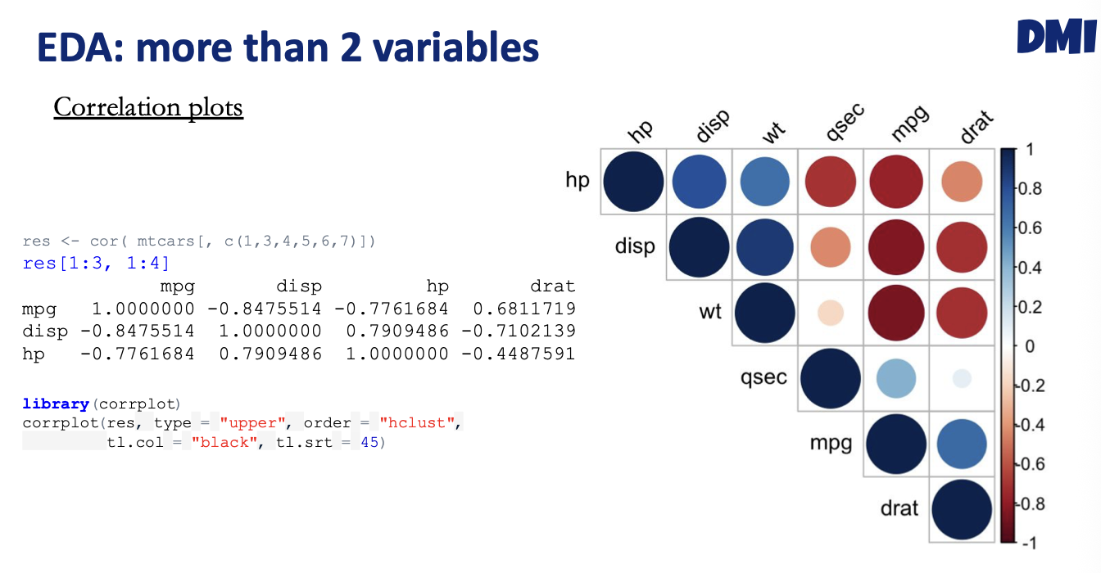

# Data visualization

## Principles of graphical excellence

Gives you the greatest number of ideas in the shortest time with the least ink in the smallest space.

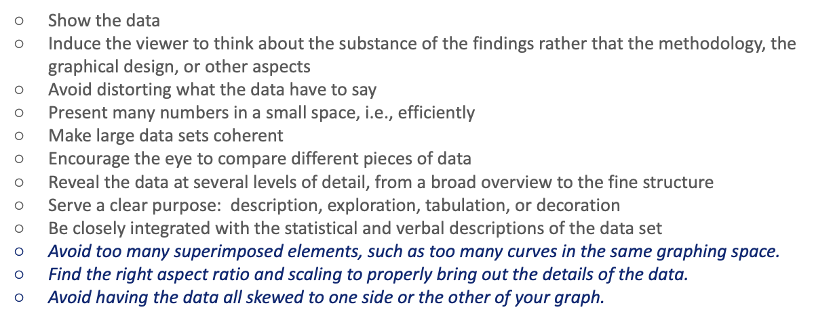

Apply **logarithmic transformation** helps group the data and better visualization.

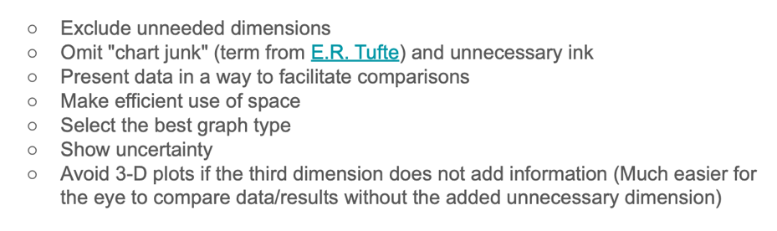



Report your results in a better way, and pay attention to some things.

## Visualization with ggplot2

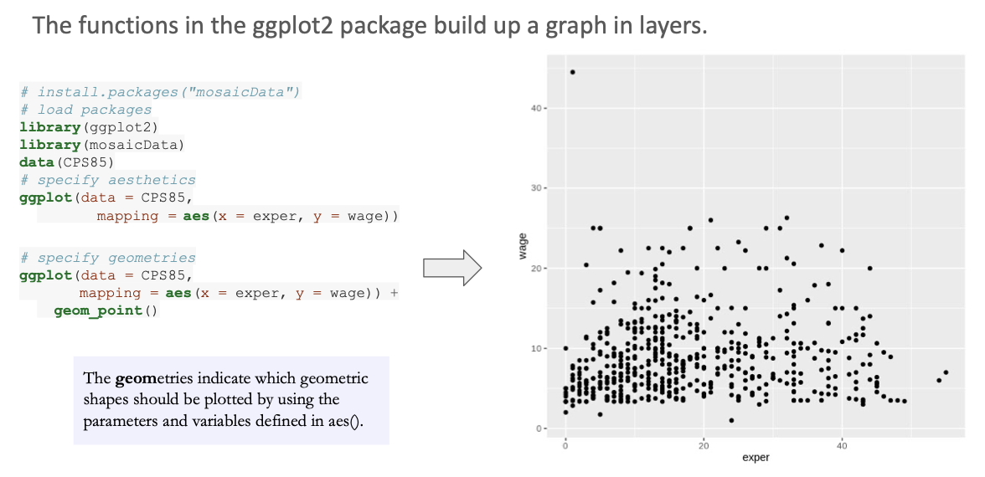

In the scatter plot we can see if there are any relations, and we see in this that there’s not. Alpha is transparency:

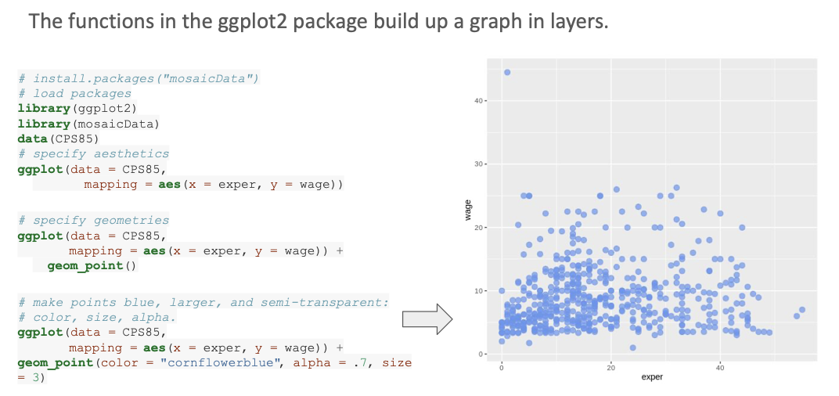, and size is the size of the dot.

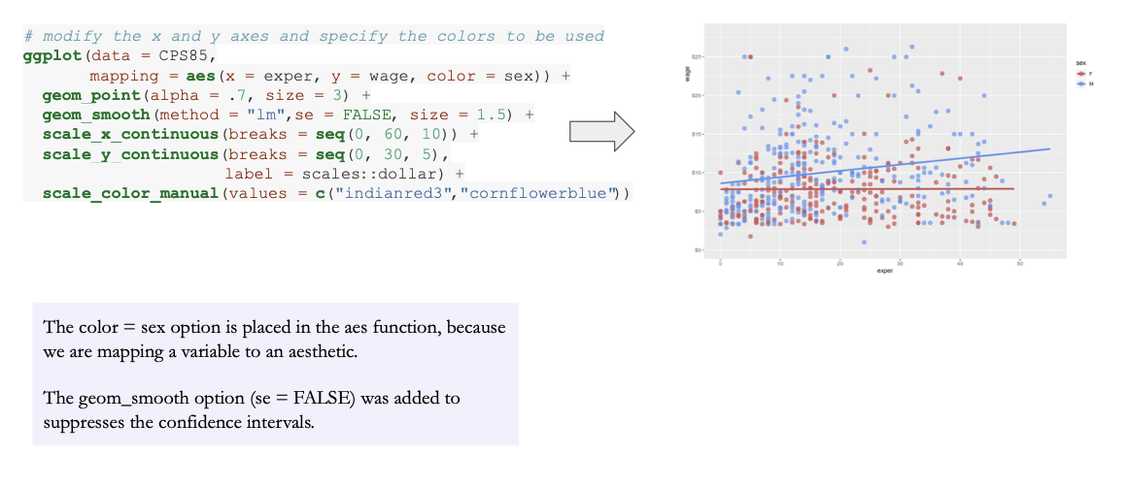

Correlation of expertise and wage for sex

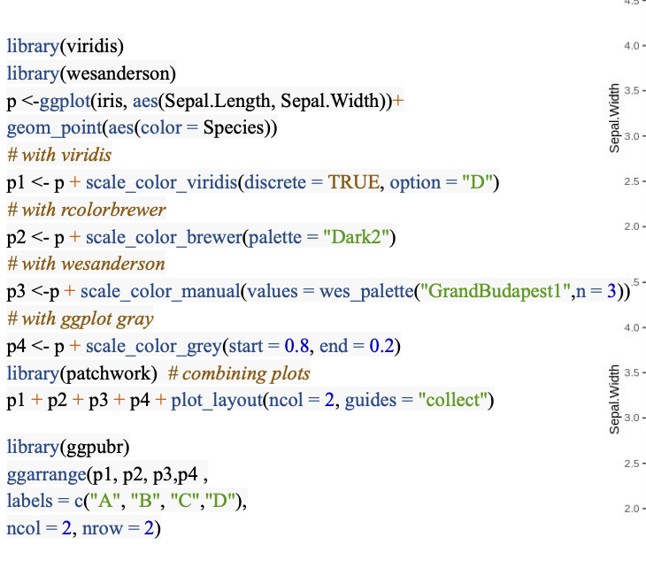



# Unsupervised Learning (I) 🡪 PCA (clustering)

Is an important part of the data analysis pipeline. We can have a paper in which we are only do cluster and present. A new classification for this cancer types and we can infer into tree subgroups based on mutations, for example.

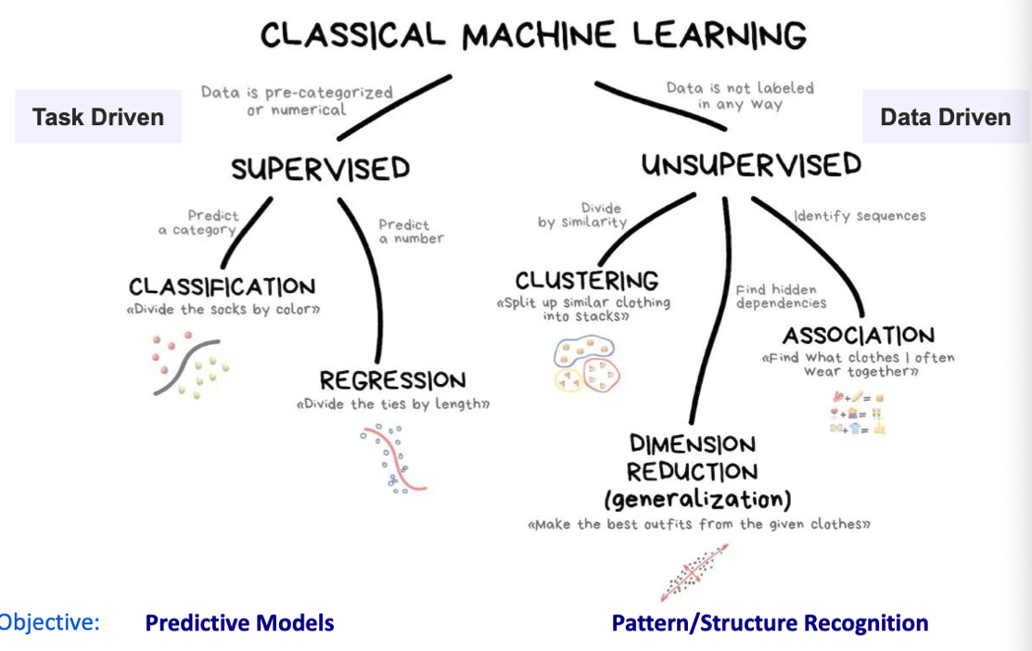

At the end we want to do a ML model but previously a reduction model:

This help to see patterns in our data and to do hypothesis generation.

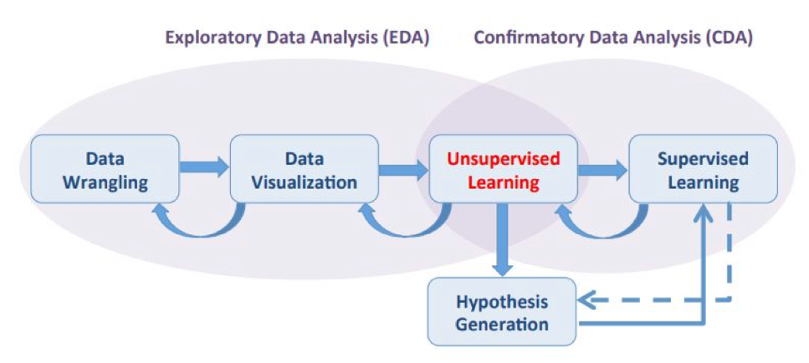

## Clustering

Find groups that find similarities between them. We see this applied to cluster genes. The problem with clustering, is we don’t know how many clusters we have. First, **remove any missing data and scale the dat**a.

### Data transformation

If one variable is age and other concentration, the distance will be driven by the one that have higher scale.

* Use scale function in R 🡪 in the proteomic data 🡪 logarithmic transformation.

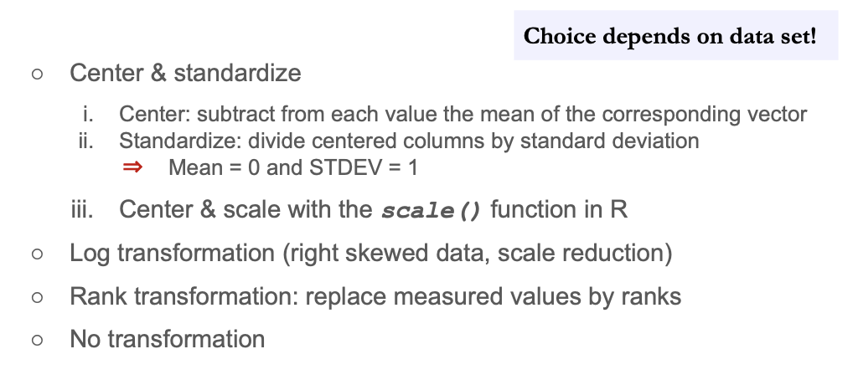

### Distance Methods

The most popular of most distance is the eucledian distance, or other ones:

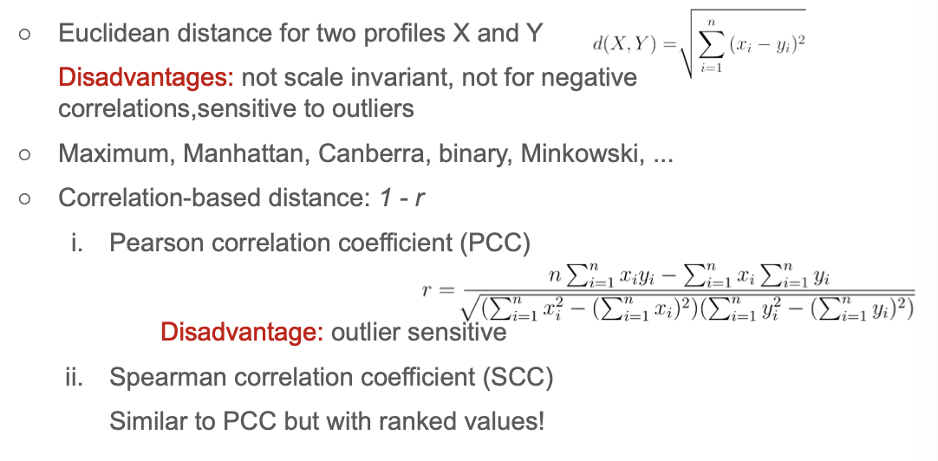

But this is so sensitive with OUTLIERS!!!! The distance based on correlation is 1-r

#### Distance in r

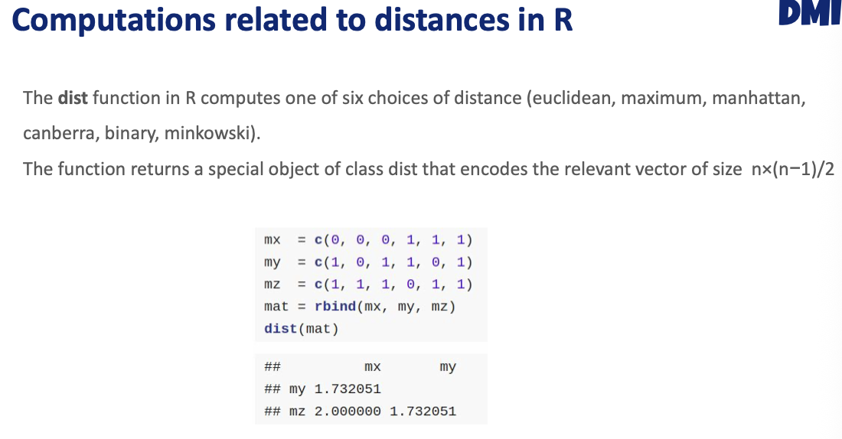

correlated

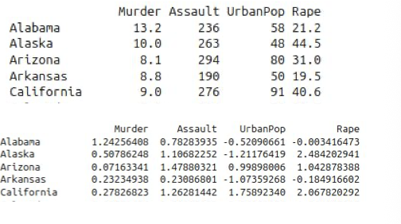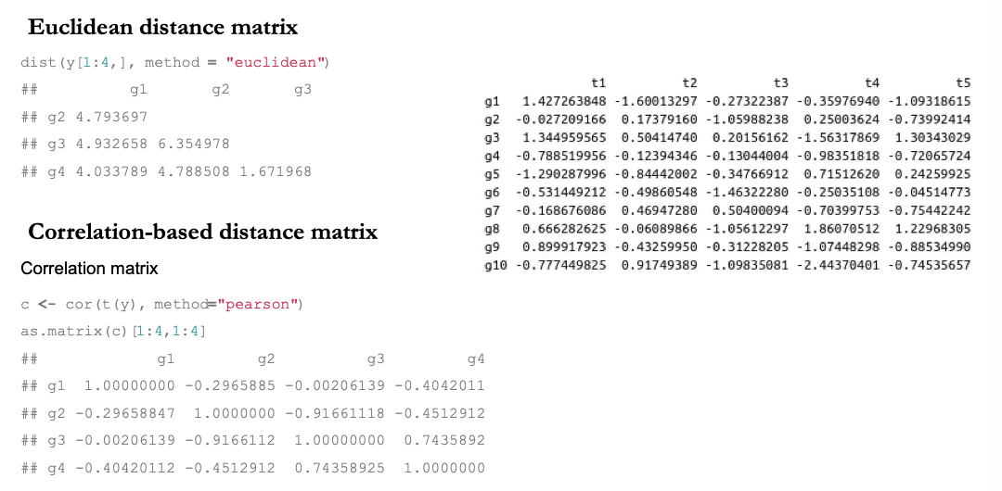

So the steps to follow are: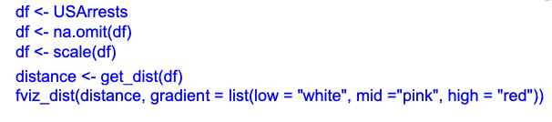

The **factoextra() package** we have to install it to do the cluster!

## Cluster linkage

Compute the minimal distance from both clusters (single linkage). Maximum distance from clusters (complete linkage) this will penalize a lot. Typically, people do the average linkage, compute the distance between all possible pairs and then do the average.

## interpreting the dendrogram

Things that are closer together, the closer they are the earlier they get fused in the cluster. Looking at the x axis is not useful, only the Y axis. This is unsueprvide,d because you can’t tell how many clusters there are:

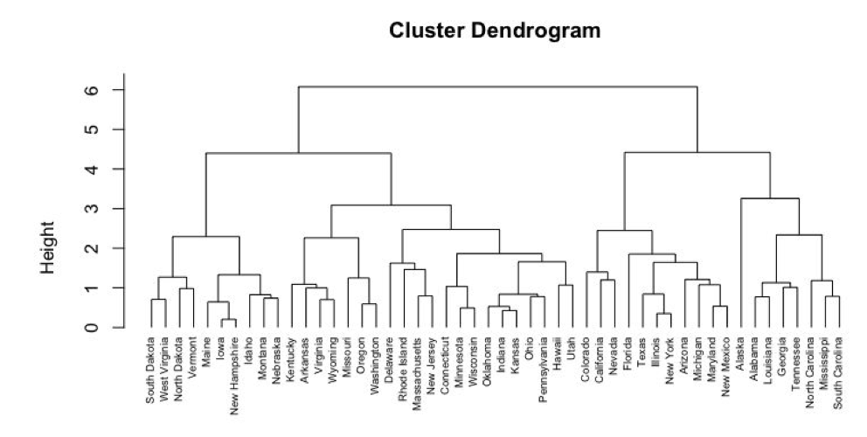

You can cut the tree in order to have how many clusters do I want.

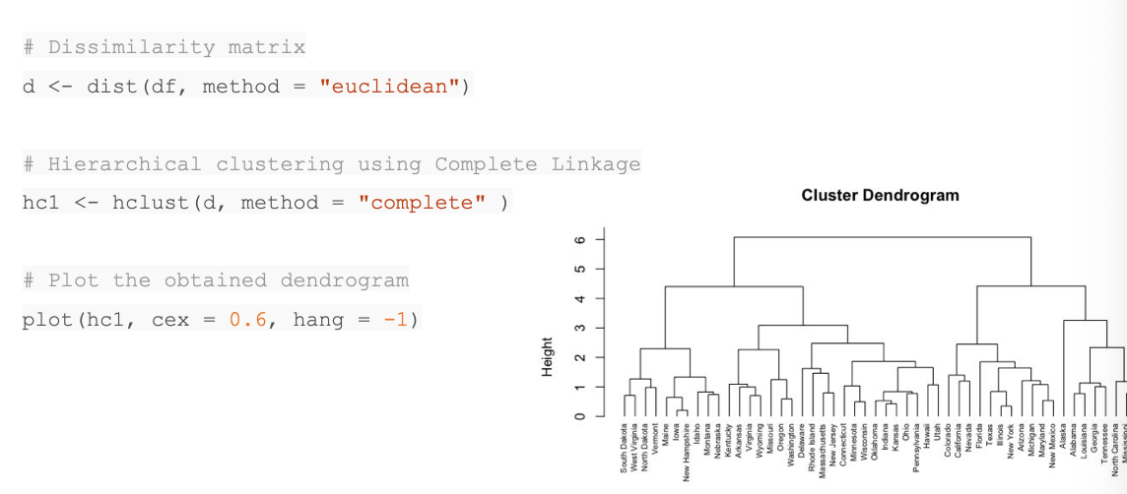

Linkage method

Distance matrix

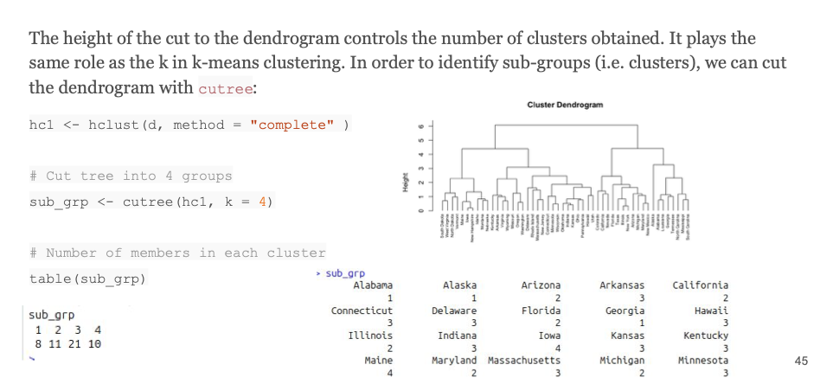



Which city belongs to each cluster

vector

K=4 is the number of clusters.

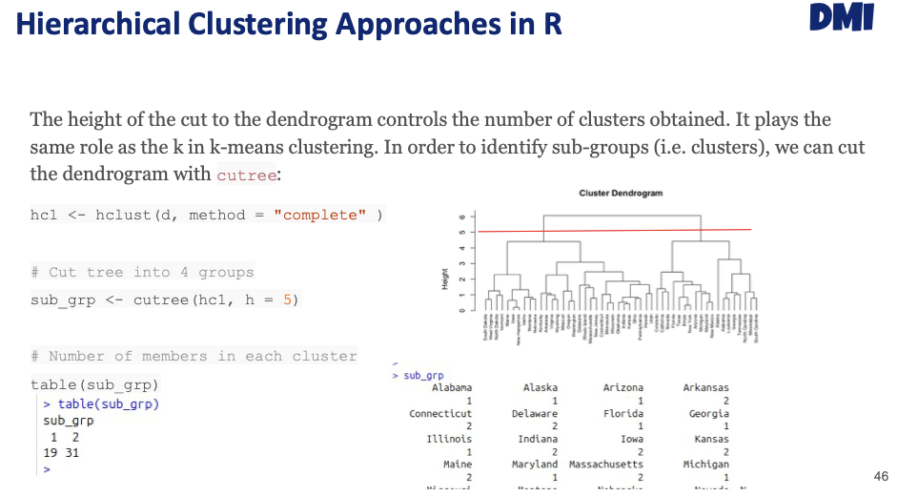

With this number, (heght of axis y) we obtain 2 clusters

## K-means clustering

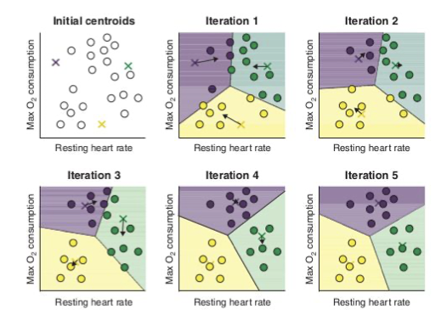In this case we have 2 clusters, and each point represent patients. First, we need to define the number of clusters we want, in this case we want 3, because we are randomly initialize 3 points within our data. In the first step, the distance between the centroid and the data will be computed to the closest centroid.

The centroid will be the average of the members of the cluster. And now we want the centroid to be the center of the cluster. Compute again the distance the samples and the centroid, and some patients (dots) might be reclassified.

always

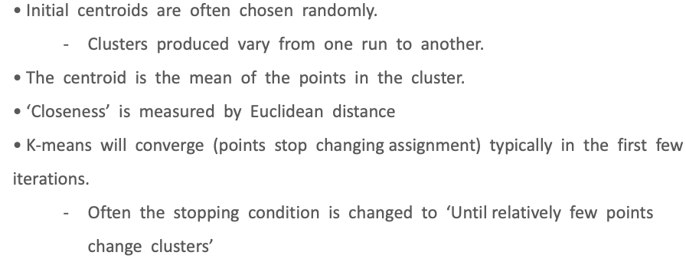

Centroid will not move anymore



Before doing the clusters, we do not know the number of clusters, so we try the number of clusters that looks better.

Number of clusters I WANT

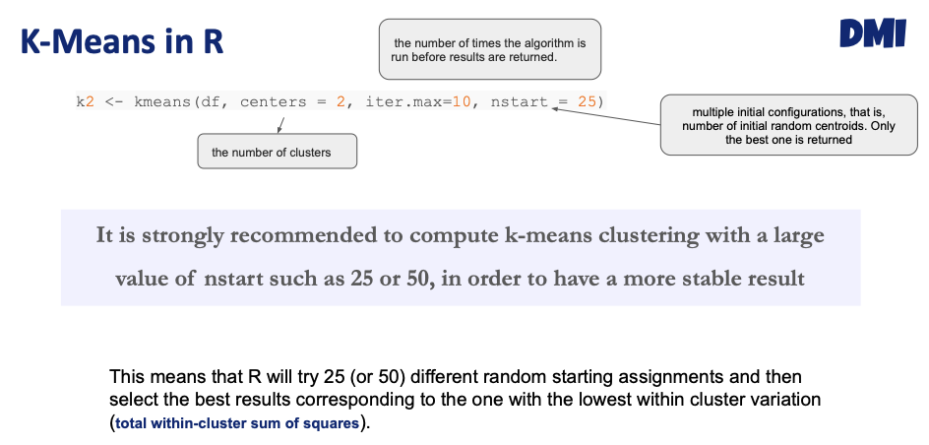

HOW MANY TIMES I going to move the centroid

NUMEBR OF TYPES WE ARE RANDOMLY MOVE THE CENTROID

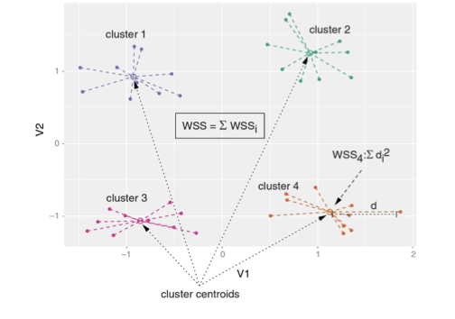we want the smallest distance between the centroid to the data points

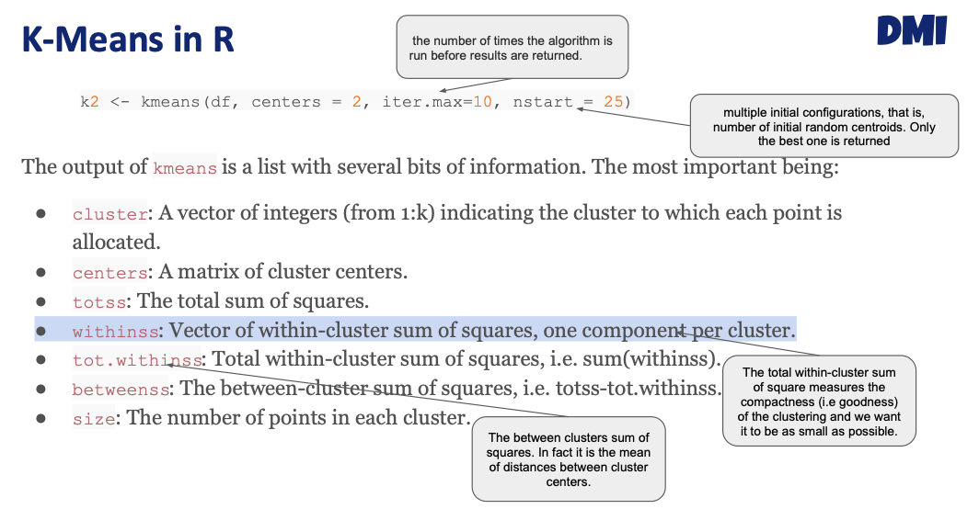

Cluster: assignment of the clusters

Totss: total sum of sq (does not take intoc account the cluster, jus thte diff between data point and average ddata points)

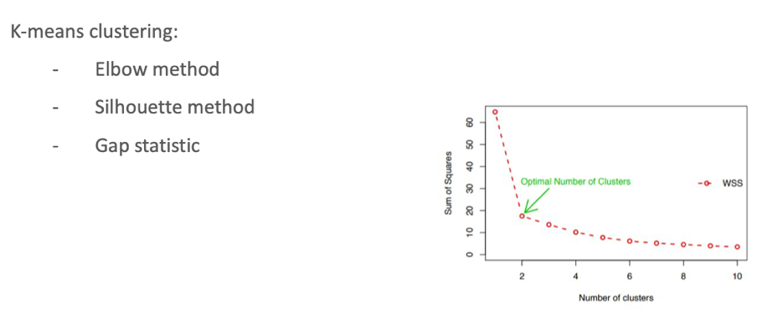

We want SS very small (they are very similrÇ9 and as the number of cliusters increases, the diatance between the centroid and data points also gets smaller. For that we need to apply the elbow method, and in this case the most optimal clusters is 2.

## Elbow method

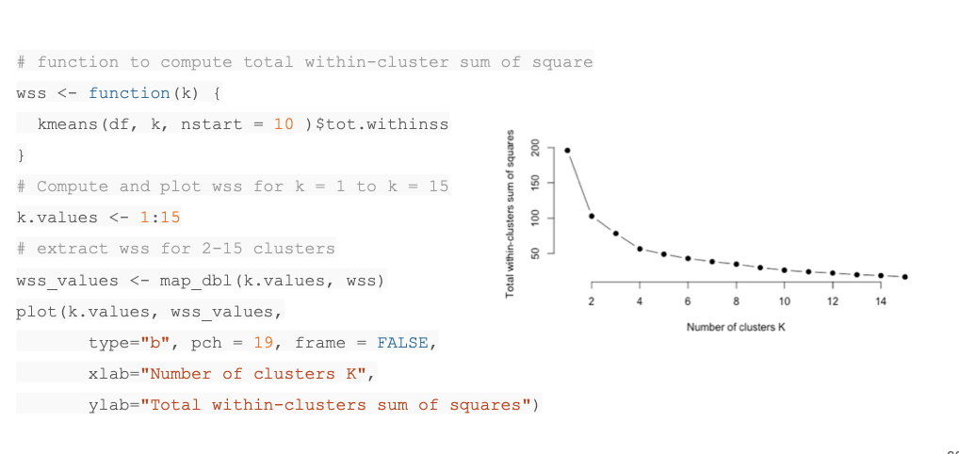

We can do it with the factoextra package in an easy war !!!!!

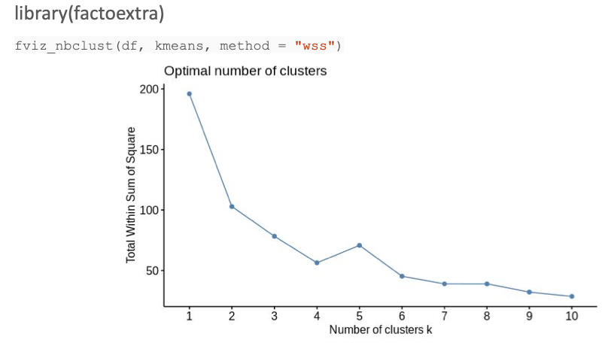



Wss = within cluster sum of squares

In this case the elbow will be 3-4.

## Silhouette Method

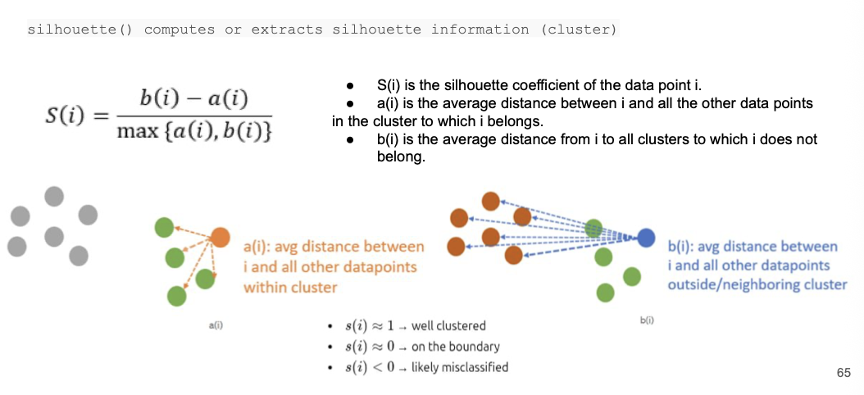

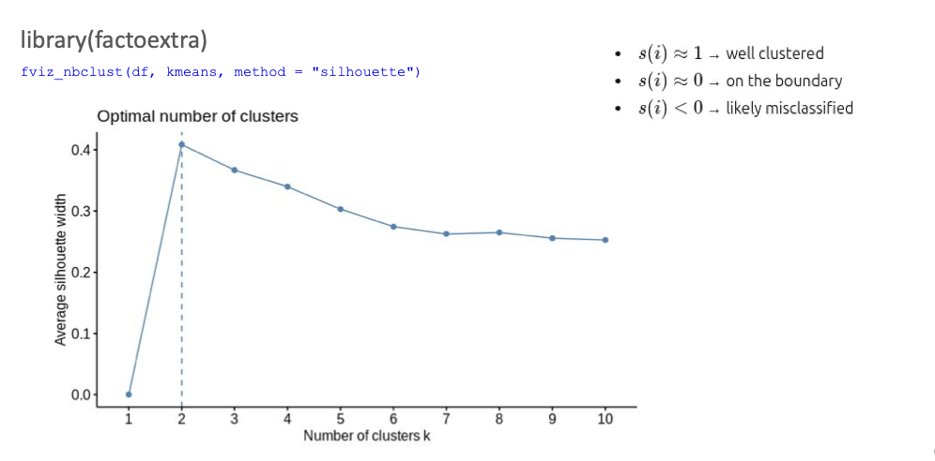



# Unsupervised Learning (II)

When having many variables, we can do dimensionality reduction.

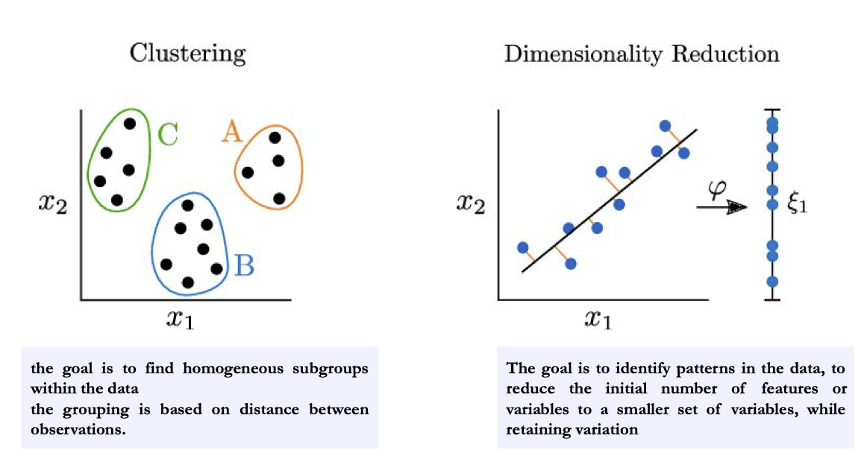

Why reduce dimensionality? 🡪 helps to visualize better the data.

# Supervised Learning (I) 🡪 basic of Machine Learning

Find some pattern in the data that classify the groups (healthy, covid-19, non-covid, etc.), that’s the reason why it is supervised. Train the ML algorithm with data, and will say the severity.

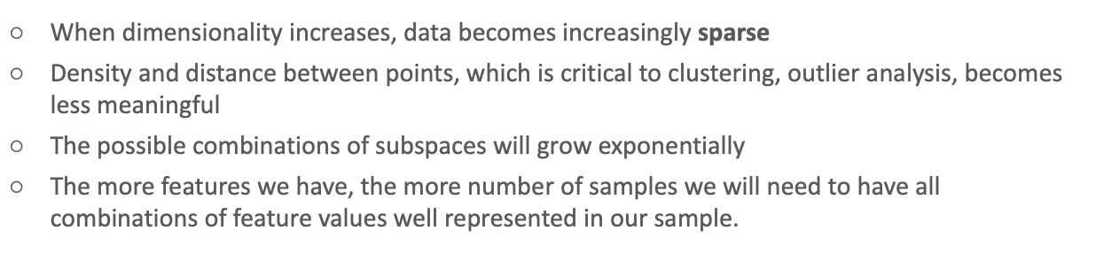



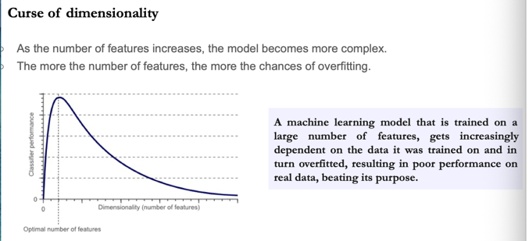



If we decrease the nº of columns that we have, we decrease collinearity (remove things that are linear, because in ML this is bad), and better for ML.

## dimensionality reduction techniques

* Feature selection
  + 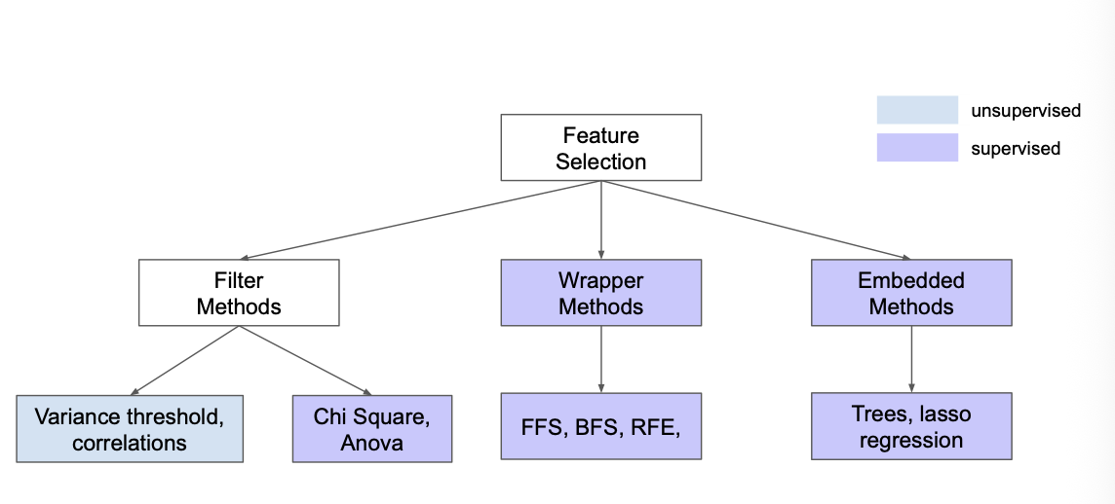
  + **Performance**: how good is the model predicting the sample
  + 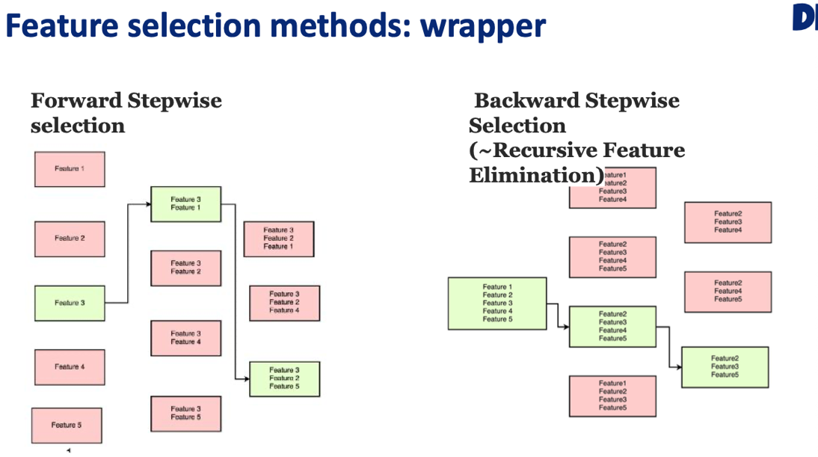



* + The best way to use feature selection is using ML, to discard the features that are not important
  + 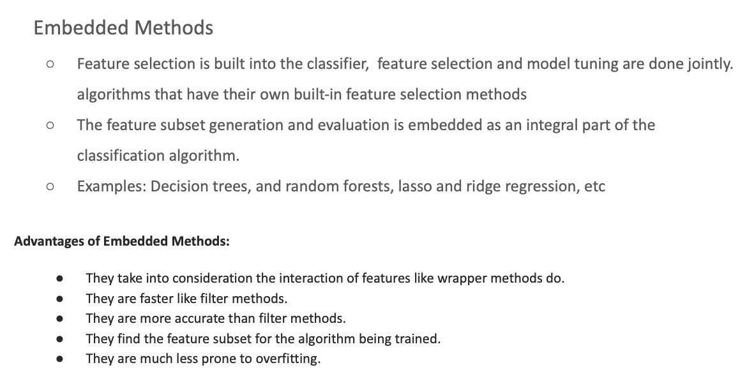



* Feature extraction
  + 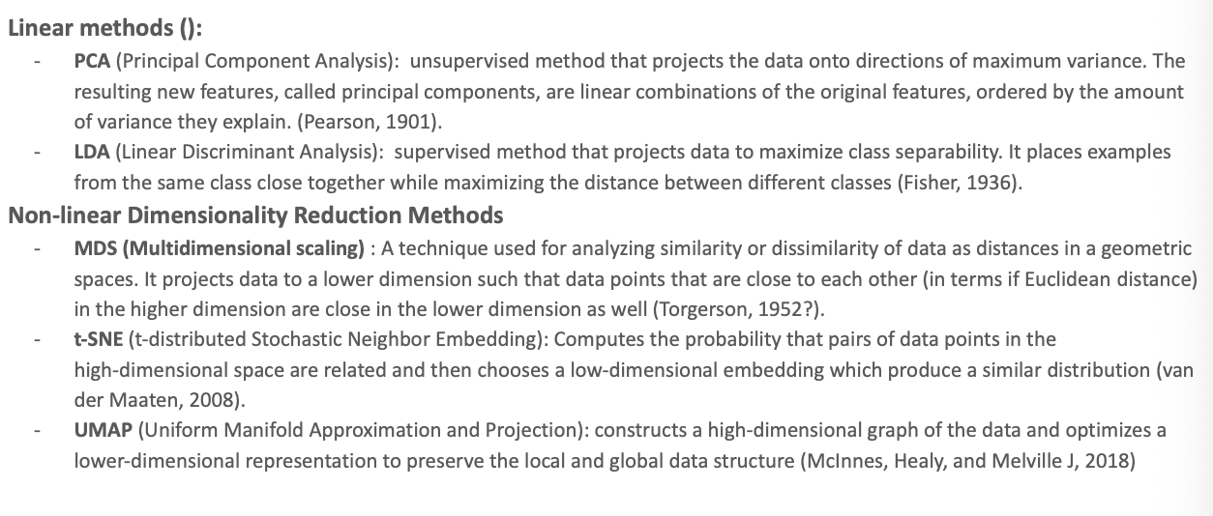

### Principal component

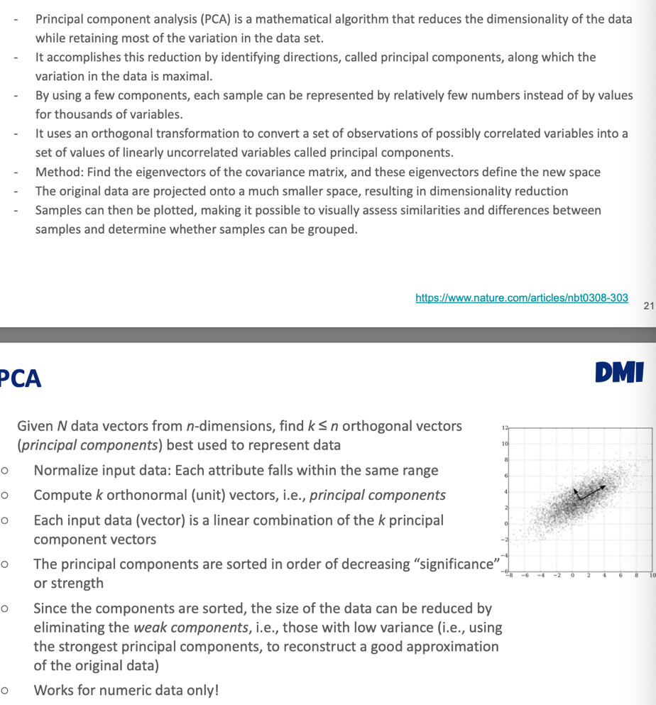

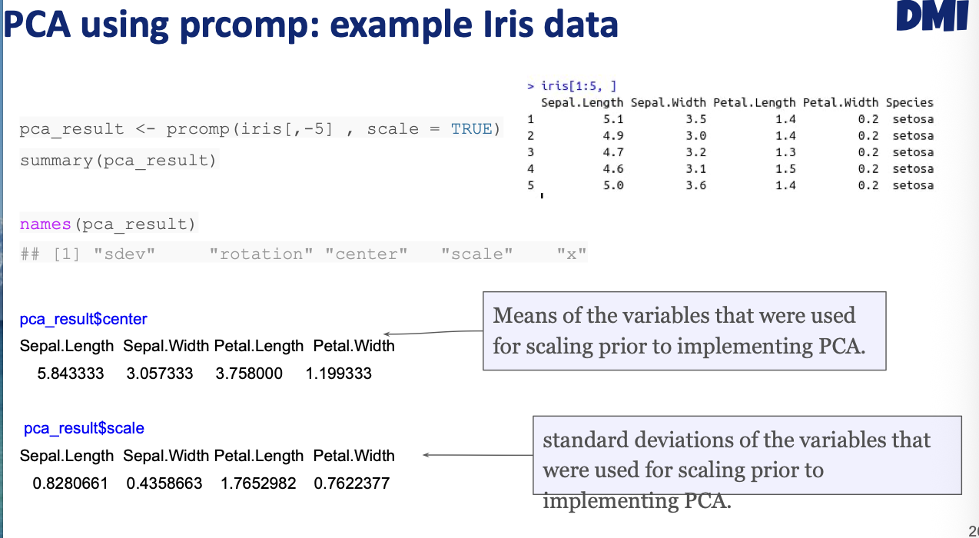

Scale your data to have the same scale

Accession to a dataframe called rotation, accessing the new features.

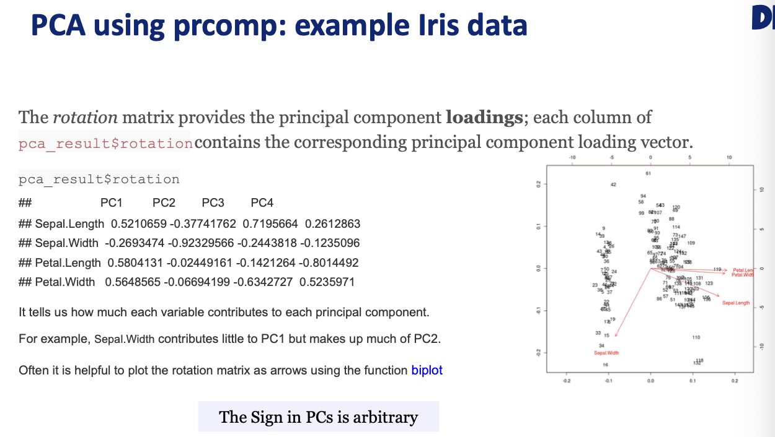

Now this will be our new data. In this case the petal length is the most important variable for PC1. And as for the PC2 is sepal width. The maximal number of PC that we are goint to have is the number of samples -1. The rotation is important because helps understand which varibales are more important for the components.

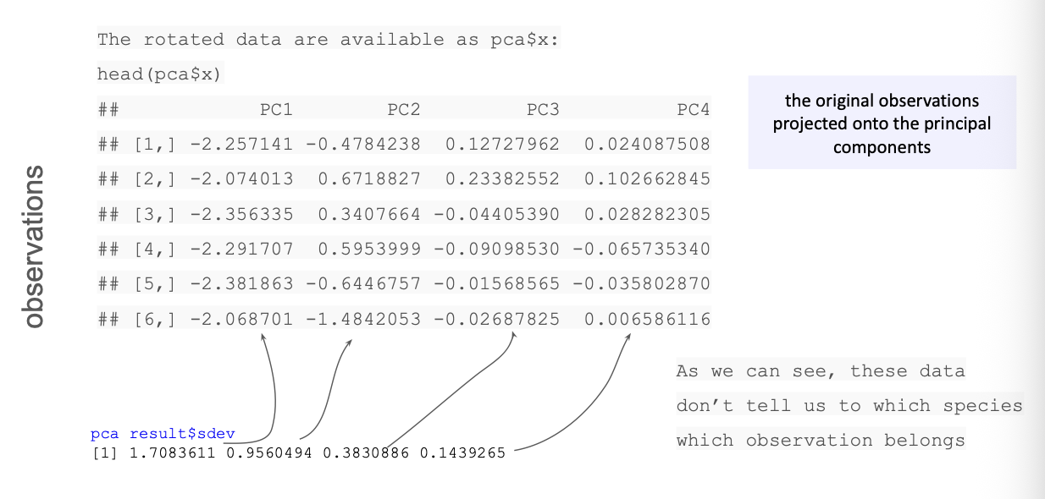

Number of samples

Acces de datafram x. Now we can plot it in 2D

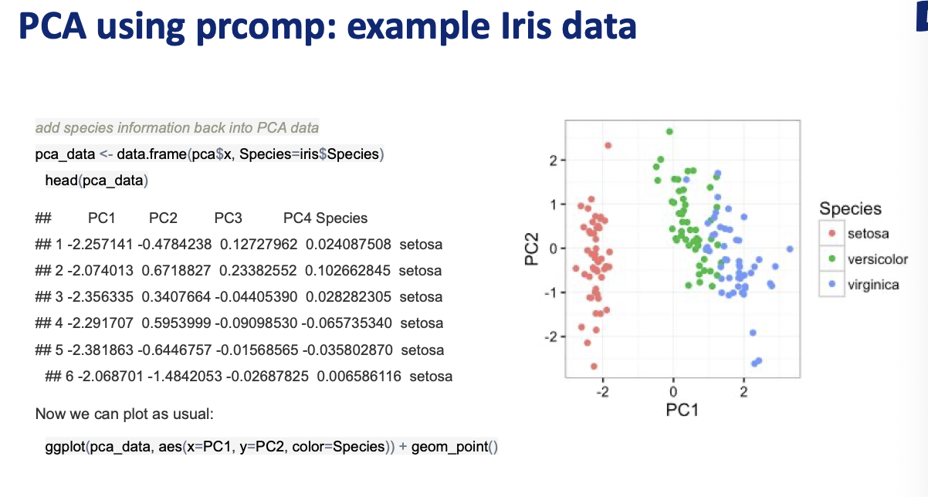

When doing a PCA we should have a plot in which the classes should be very separated by groups. How many dimensions should I save? To decide how many features should I keep, we do this plot:

Tells the % of variance for each component:

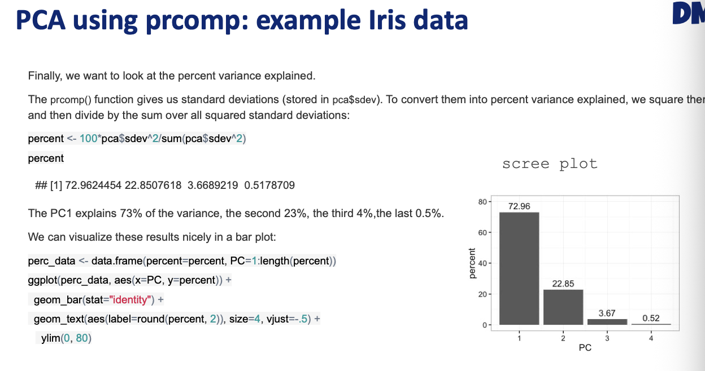

The first variable, explains 72% variance between this two components, and with the two first components, I explain 99% of the data, and the others I can get rid off.

When working with PCA, we should use this package:

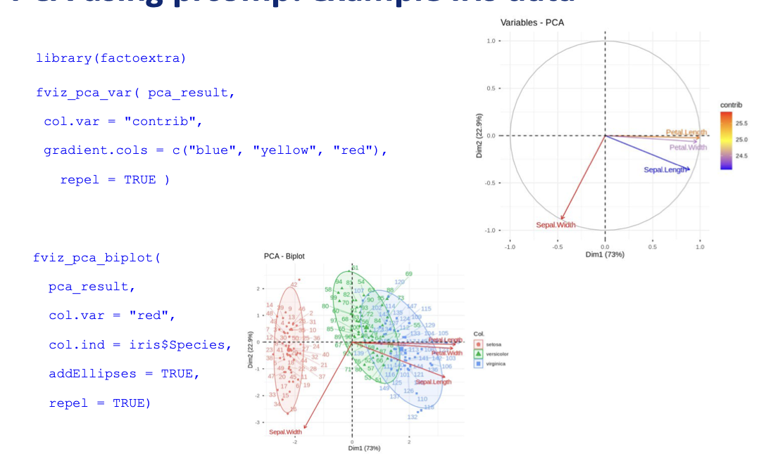

This are the rotations, and int the first plot you see how far each component is far. The red thing explains a different thing (is orthogonal) with respect to the other ones that explain the same. In the second plot, not plot the numbers, but the elipses and are the high density areas for each group. We will see the different groups of patients, and the proteomics data helps separate groups of patients.

## How to do a t-sne

T-sne and UMAP deal with non-linearity. 2-3 PCA. The most important parameter is perplexity, the bigger, the most focuses on the global. Good at finding samples that are close together.

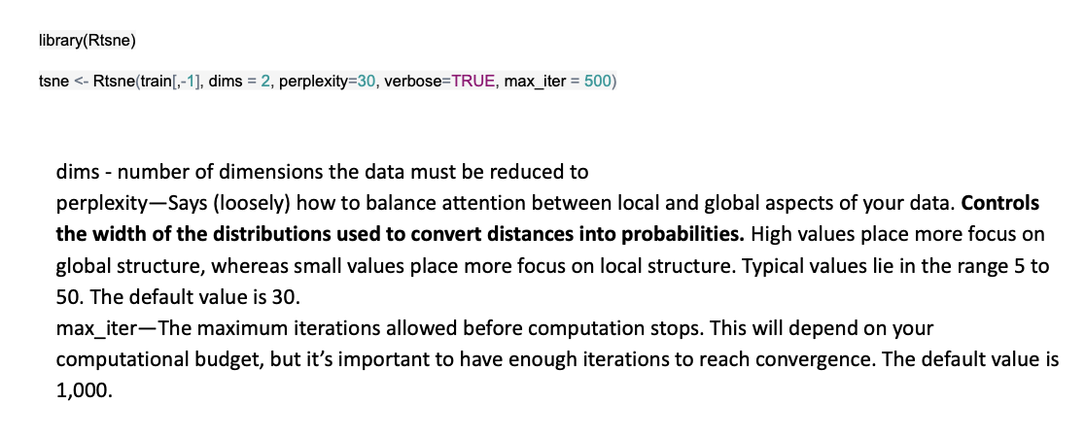

## umap

Preserve better the local structure

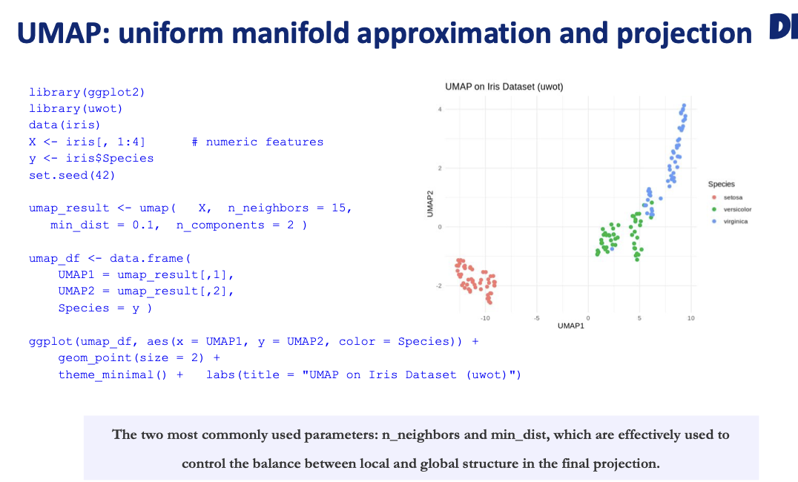



What is the size of neighbors for this sample, the bigger the number of neighbours, the more I take into account he global sutrcture.

## Dimensionality reduction methods

# Supervised Learning (II)

Uses labeled dataset to train algorithms to predict outcomes and recognize patterns. Each input adata has a corresponding output. On the other hand, unsupervised learning involves training the model with unlabeled data which helps to uncover patterns, structures or relationships within the data without predefined outputs.

Unsupervised learning 🡪 clustering

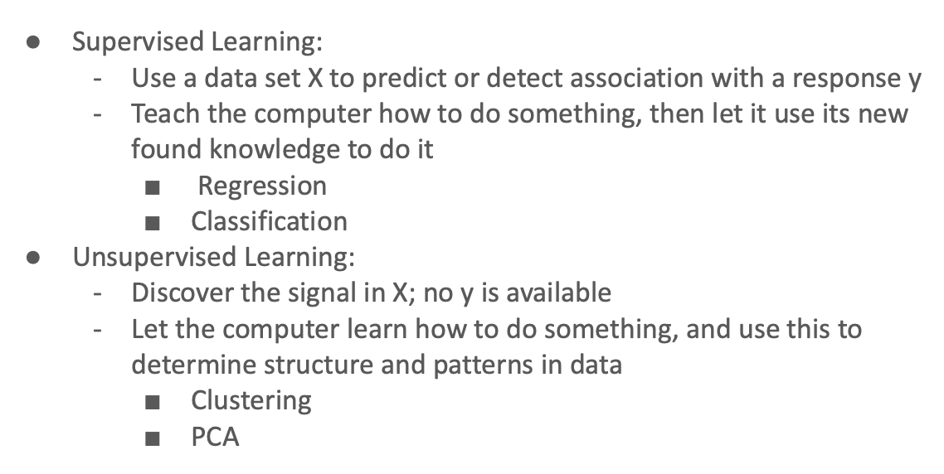

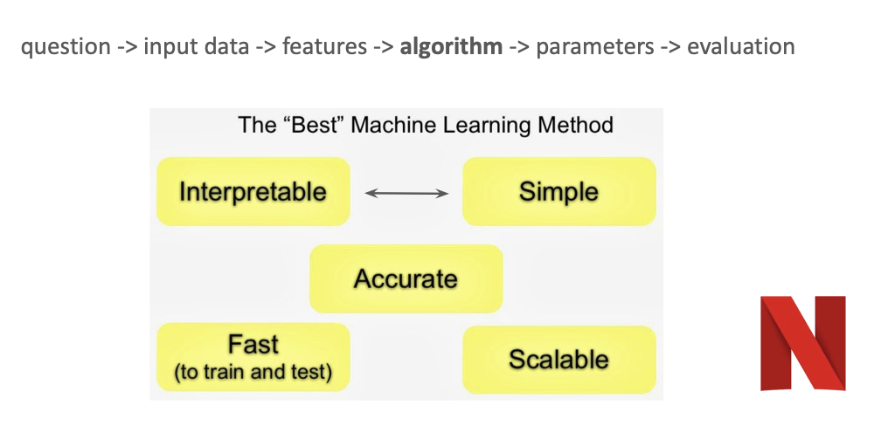

The most important thing. For instance NN are not interpretable at all, but decision trees yes.

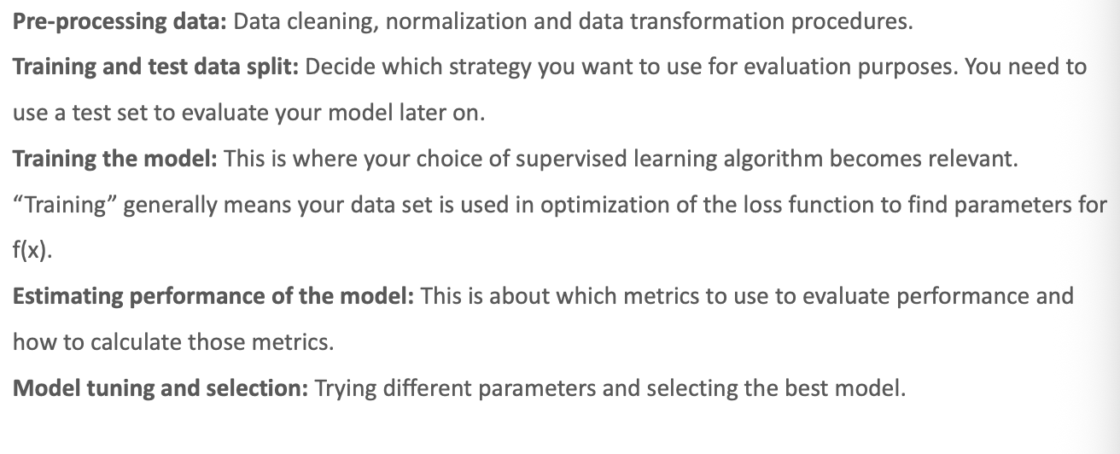



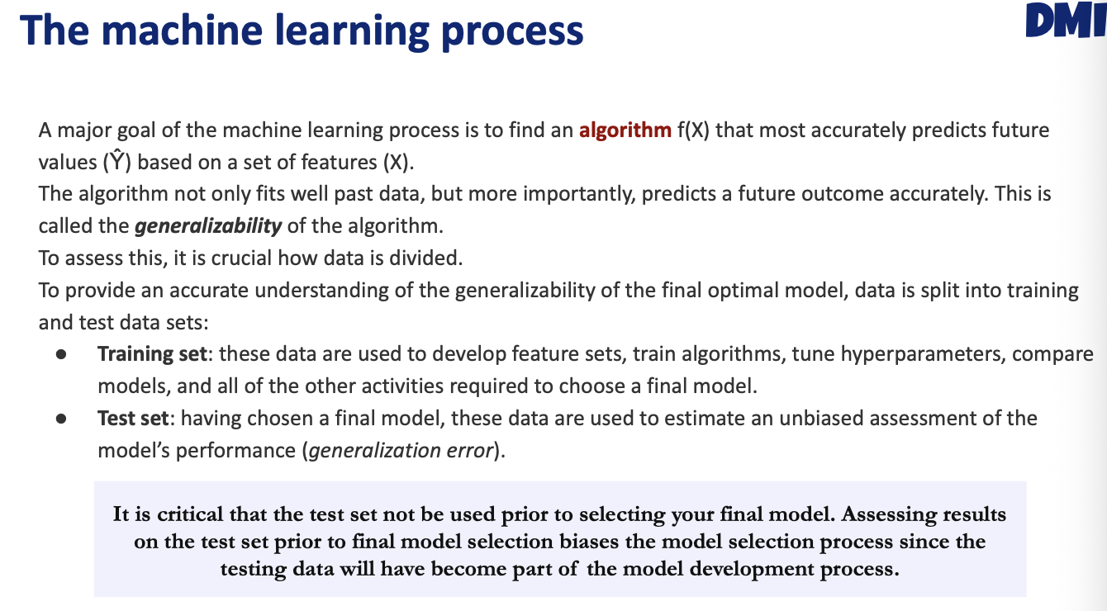

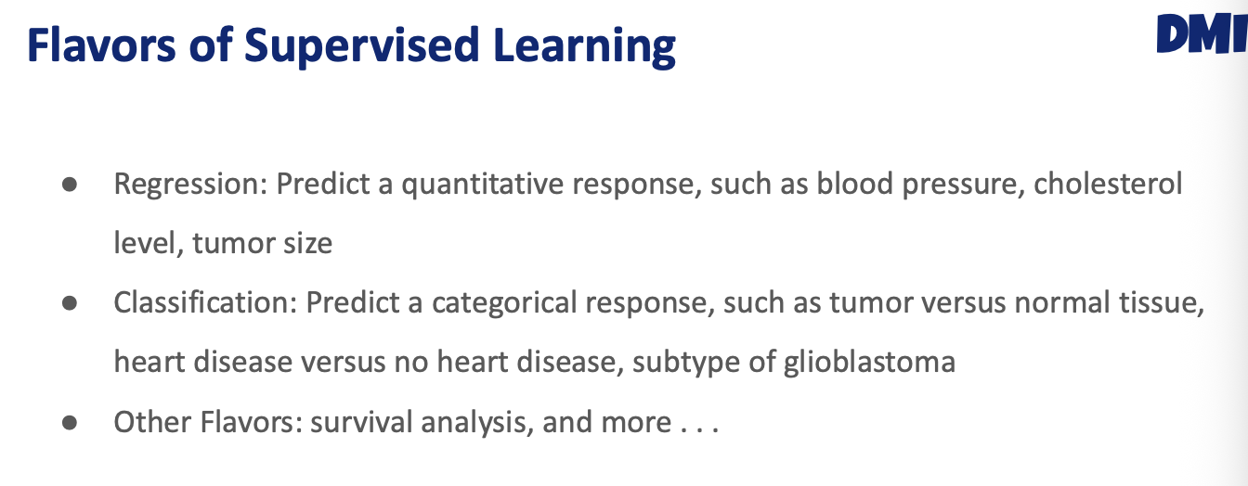



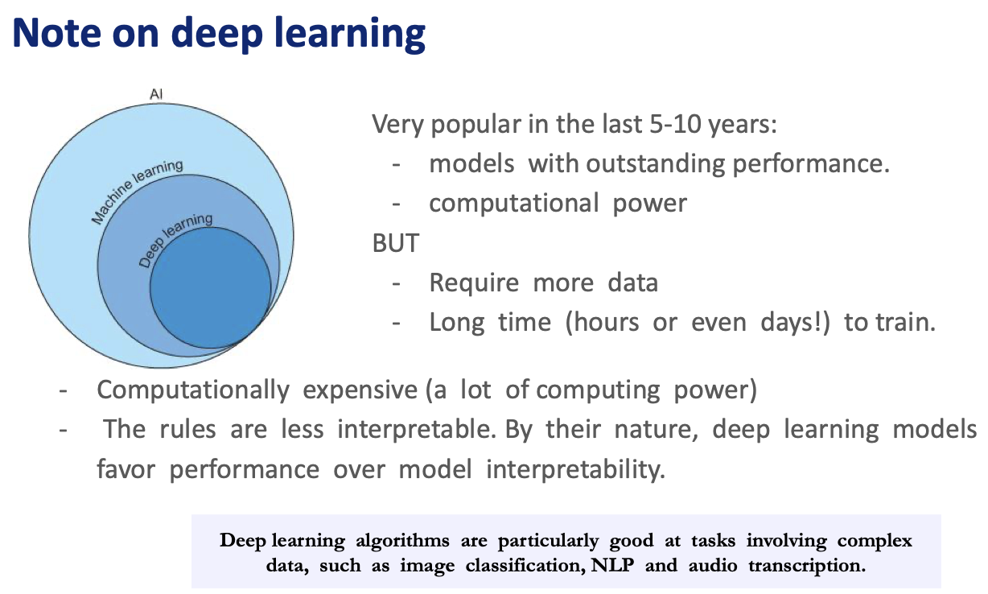



## Classification

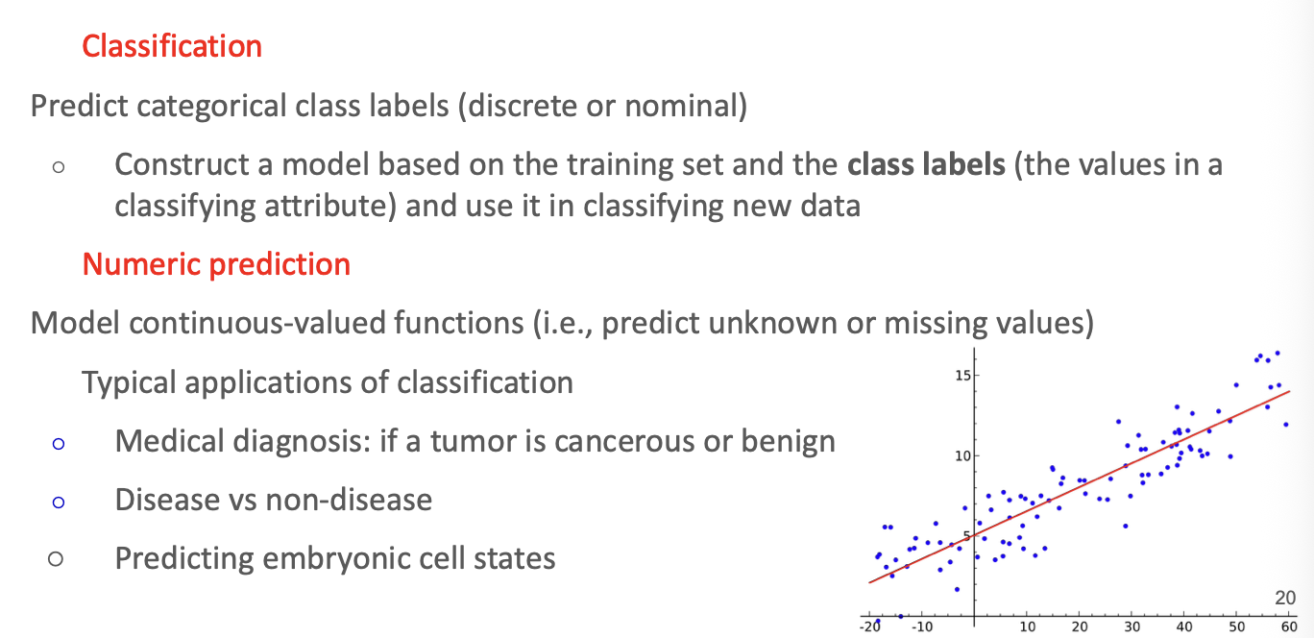

Want to verify the performance of my model that we have not seen yet. And we don’t know if it is generalizable.

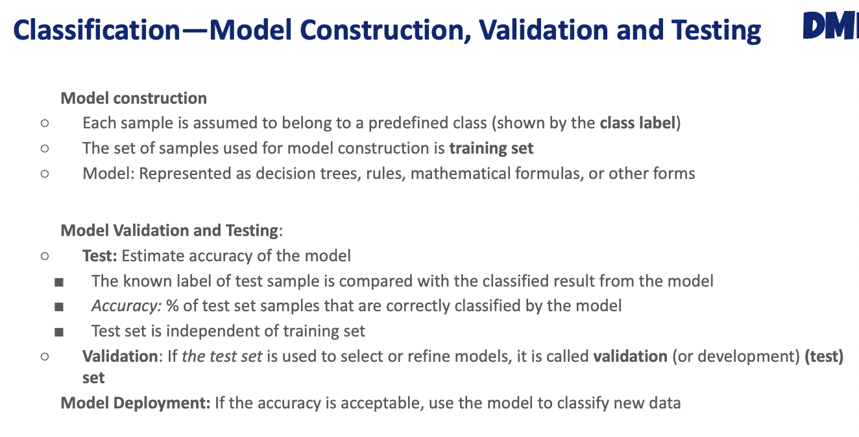

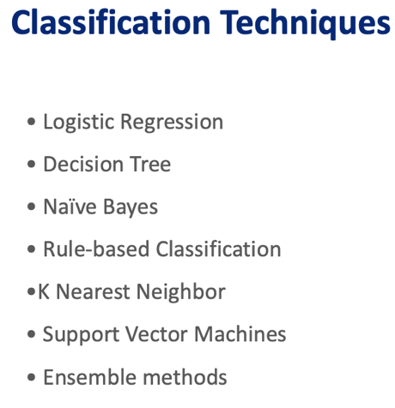

### K nearest neighbor

Based on the similary with the neighbours and it is based on the eucledian and Manhattan.

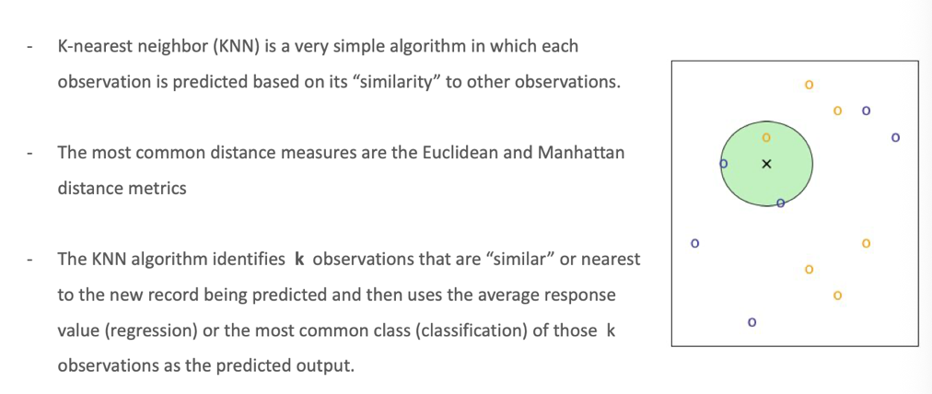



1. Compute the distance for the x data sample with the rest of the training set.
2. Decide how many neighbors we have to take into account

Scale the data!!!!!

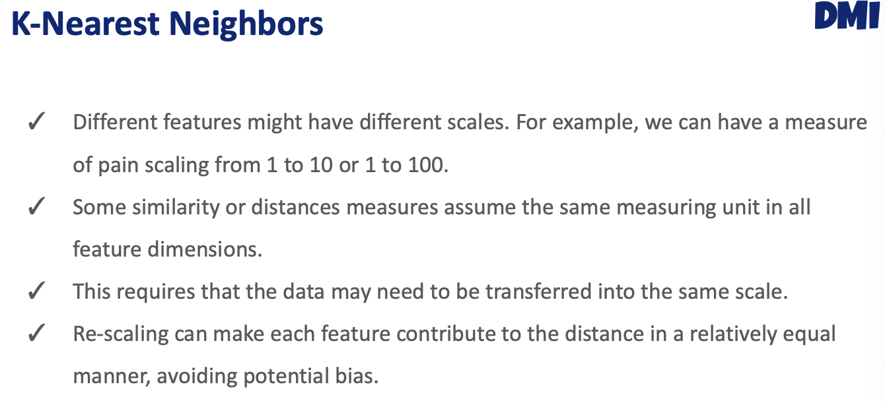



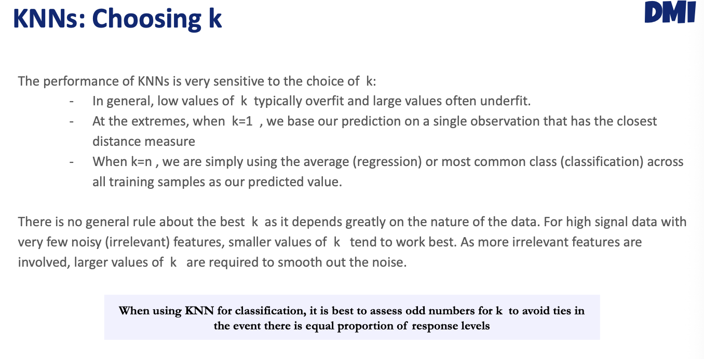



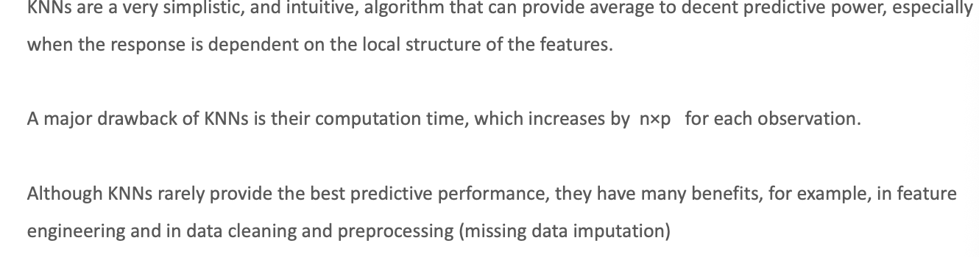



### Decision trees

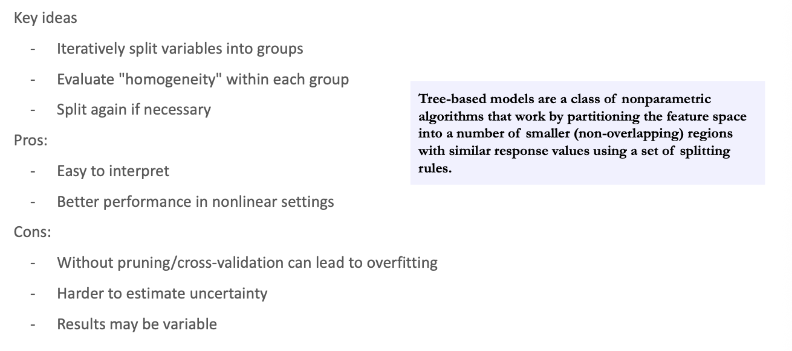



Most interpretable



In this case, we have features of the cell, and given the sample, we have to predict the label of the sample. We take every feature and we split the data.

benigne

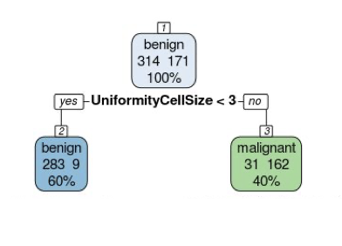

maligne

If taking the Uniformity cell type is less than 3, are bengine, and if not, 190 or so are malignant. Our dataset is split into two, and the benigne is the huge one. So this one feature is very good to split our data. We are going to keep splitting.

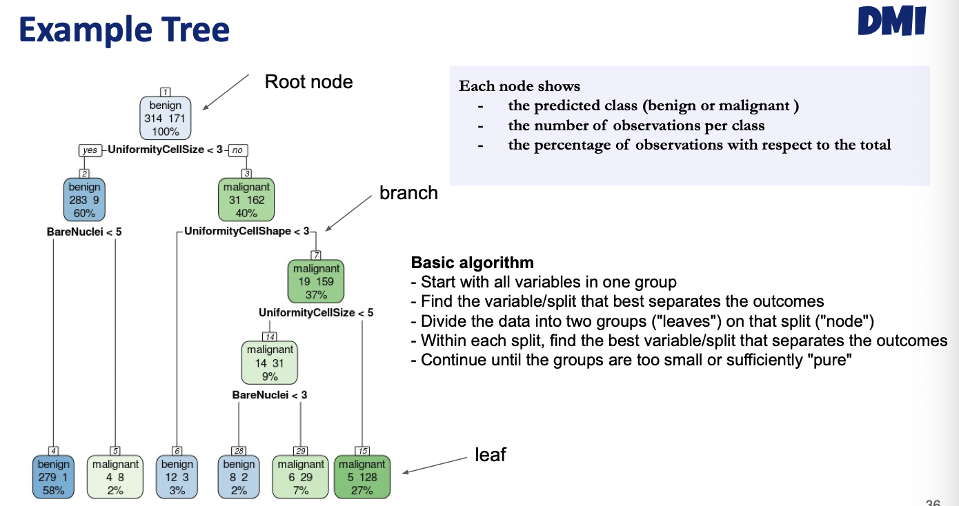

Not really homogeneous



Here we are using another feature, which is Brenuclei and uniformity cell shape and so more. S we have a combination of splits that allows us to separate further and further our data. And also tells us the purity if the leave (hoja) es homogeneous or not (just on class). The higher the purity of the node, THE higher the feature. How do I evaluate the purity of the node?

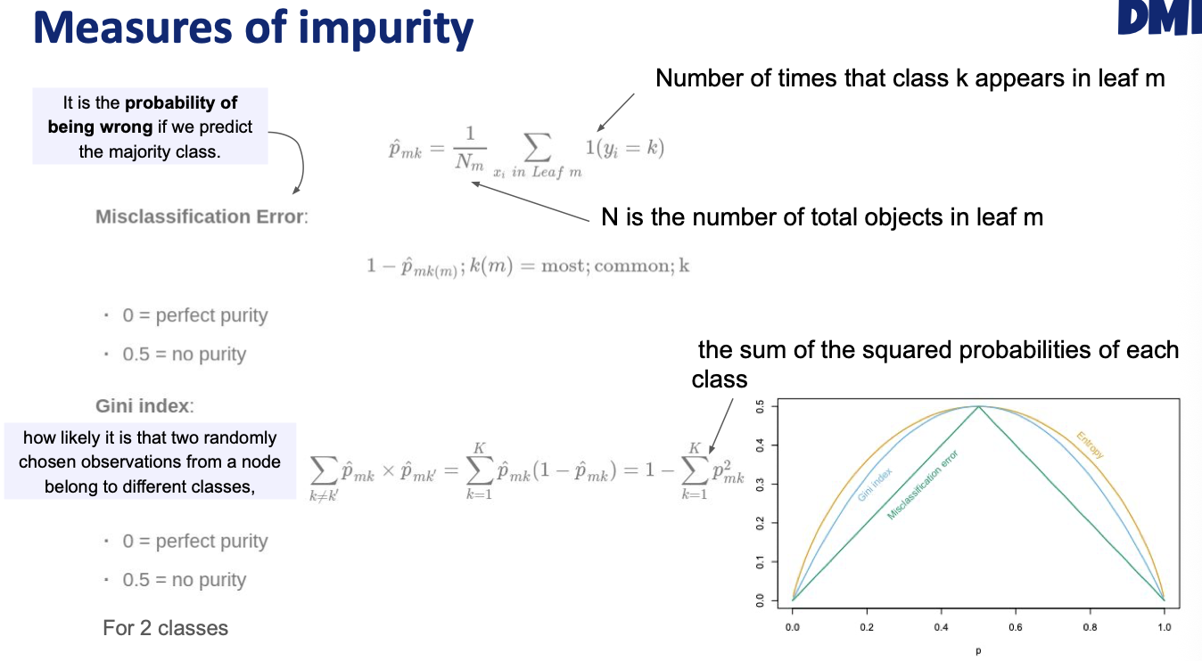



How pure our node in our decision tree is. 0 == perfect purity, 0.5 == bad split.

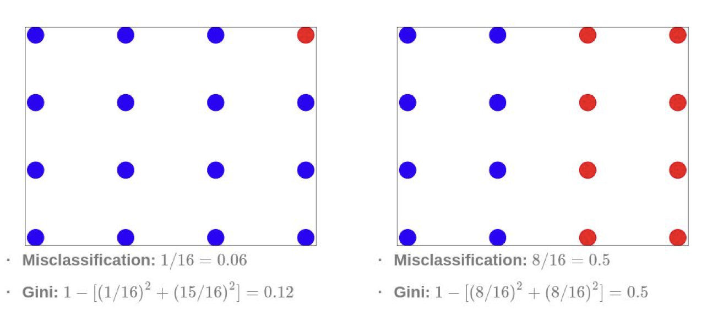

Probability of finding a red class = 0.5

Missclassificaiotn error is 0.06

We have to check how close to 0 is, to compare with another feature or split.

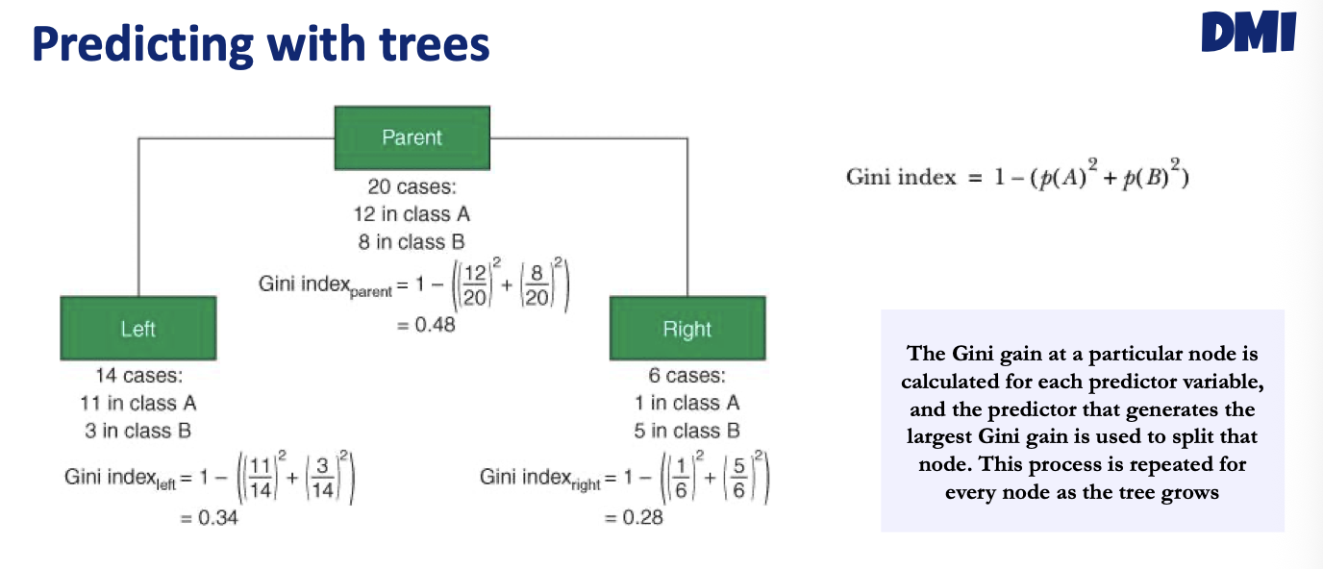

First compute the gini for the parent. The purity is very bad, really impure. How to know the son split is better than the parent? We do a weighted son:

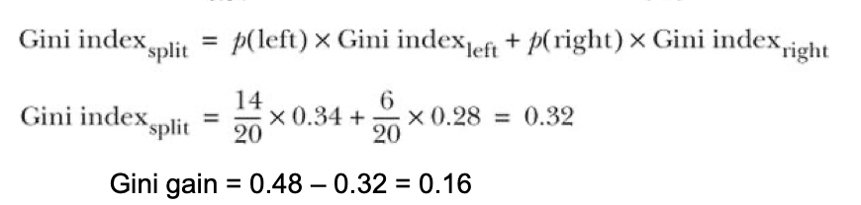

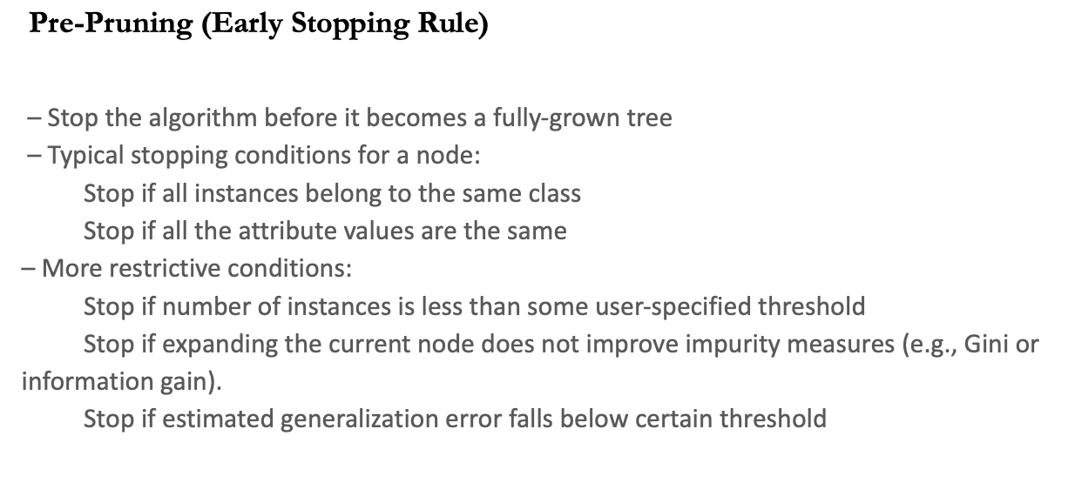



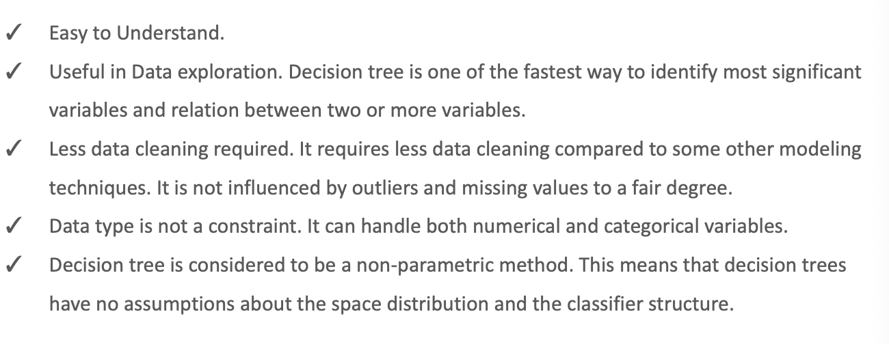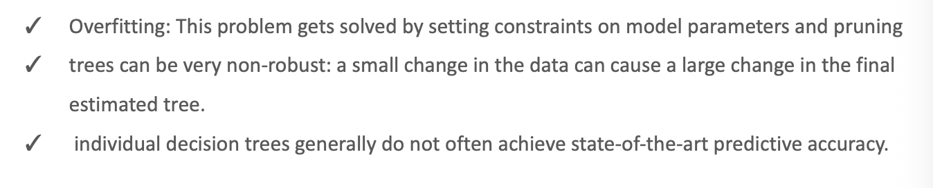



## How do we know how good our model is?

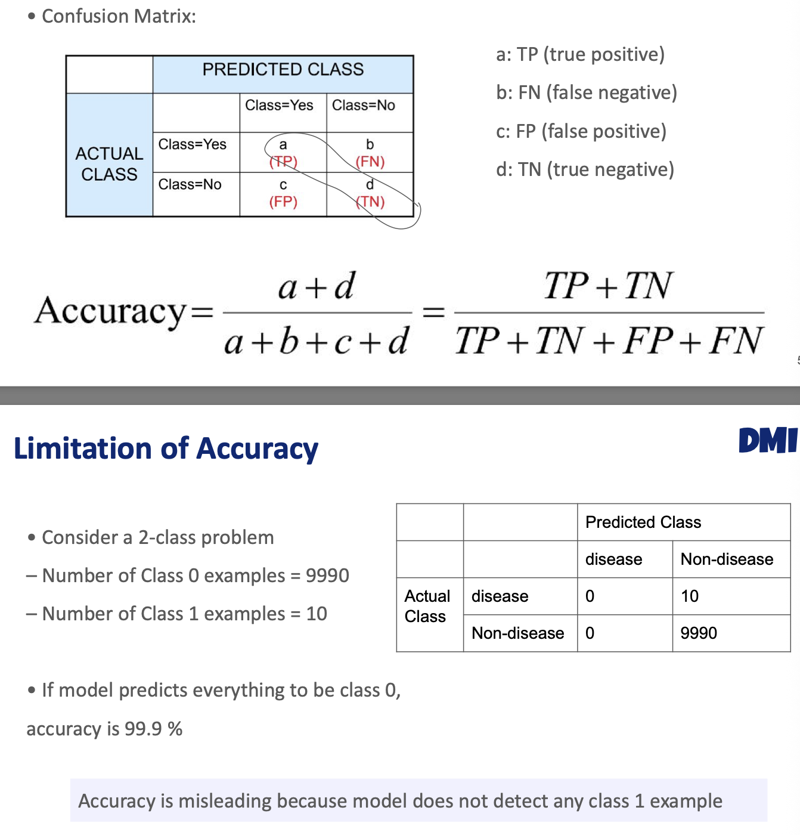

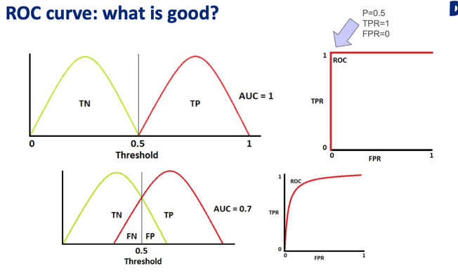We want a perfect dataset, below 0,5 is benign, and upper malignant, but in biological samples we would never have that. Instead, we will have:

For that I would lower the cutoff here

## Simplified view of the ML pipeline

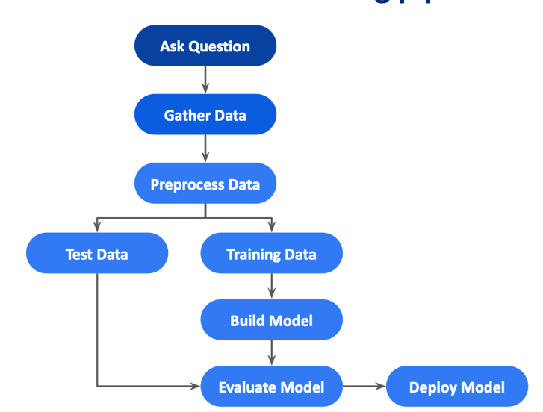

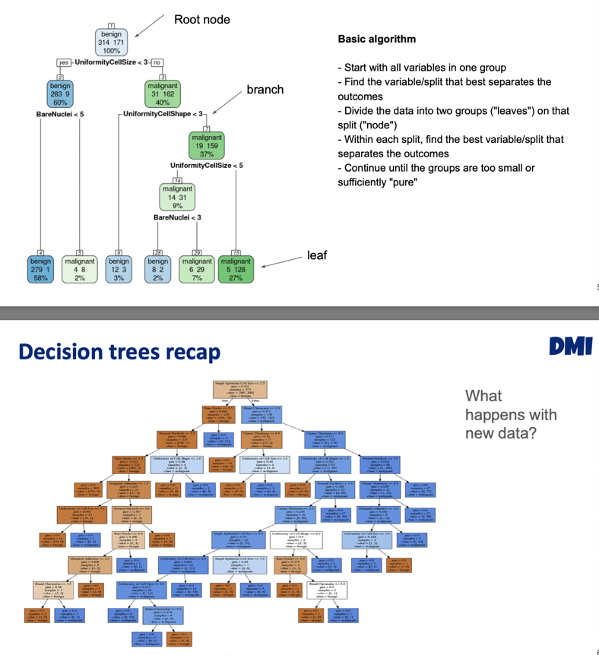We use the value of K from the training data and apply this to another dataset.

The green decision tree is more shallow than this other one

overfit

More splits, more correctly assign the data. The performance of the more deeper tree will be worst. Creating a more complex model, that can do perfect performance with the training data, but behaves bad for the original set.

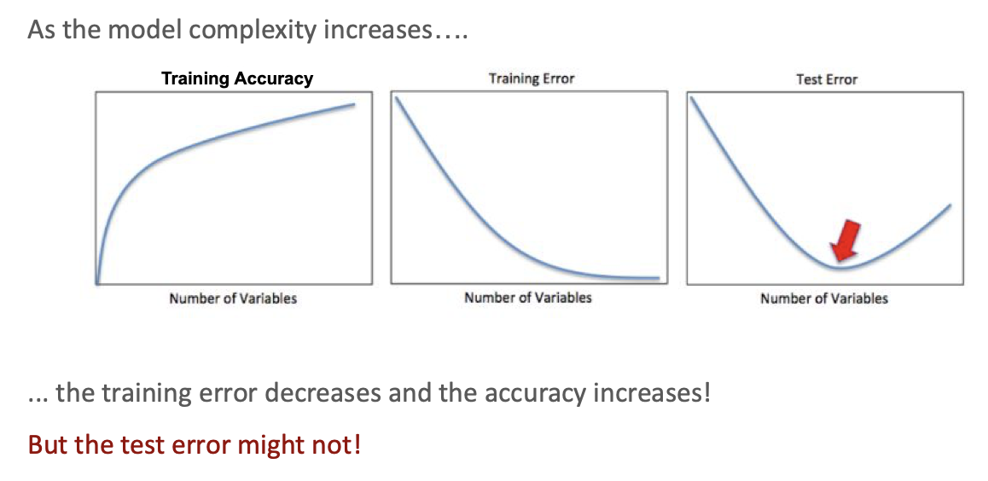

* As the model complexity increases, training error always decreases

Model complexity is a key concept in supervised learning:

* But the test error might not

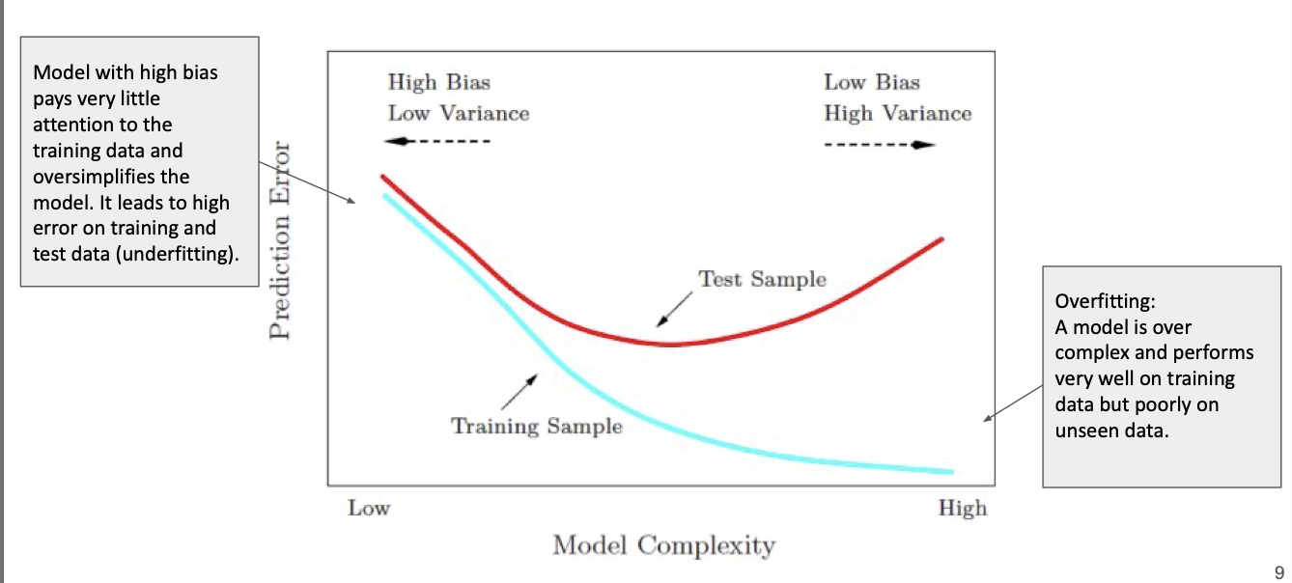

* **Bias**: difference between the expected prediction value and the correct response value
* **Variance**: the variability of the prediction values when we construct models multiple times with different training sets for the same problem.

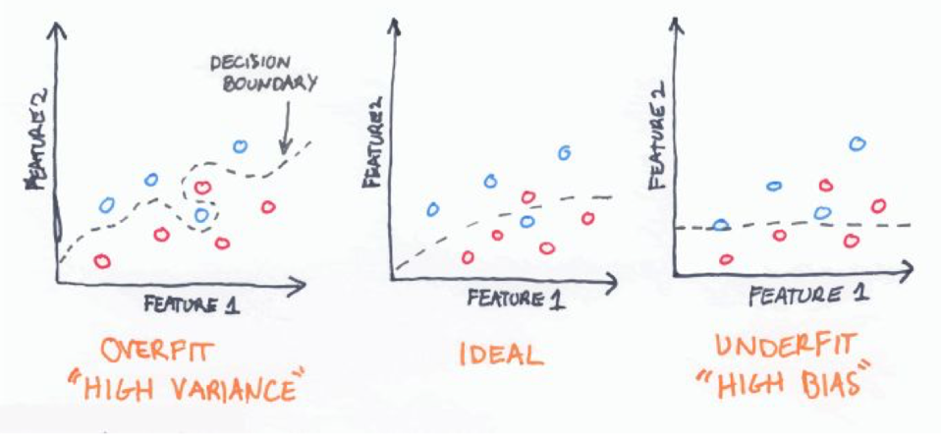

## BIAS-Variance Trade-off

Every ML model has a hyperparameter, for instance, in the knearest neighbor k is the hyperparameter, some thing we can control.

Because we typically like to explain away as much variation in our data as possible, and because we often have many more variables than are important for our problem, **underfitting is less frequently a problem than overfitting.**

Since high variance models are more prone to overfitting, using resampling procedures are critical to reduce this risk. Moreover, many algorithms that are capable of achieving high generalization performance have lots of hyperparameters that control the level of model complexity (i.e., the tradeoff between bias and variance).

Need second data to evaluate the hyperparameter, without touching the test data.

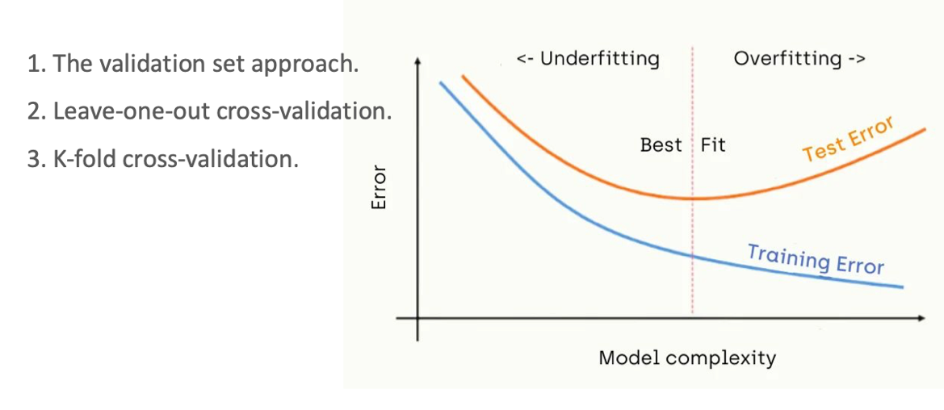

3 ways to estimate test error with training data

VALIDATION SET APPROACH:

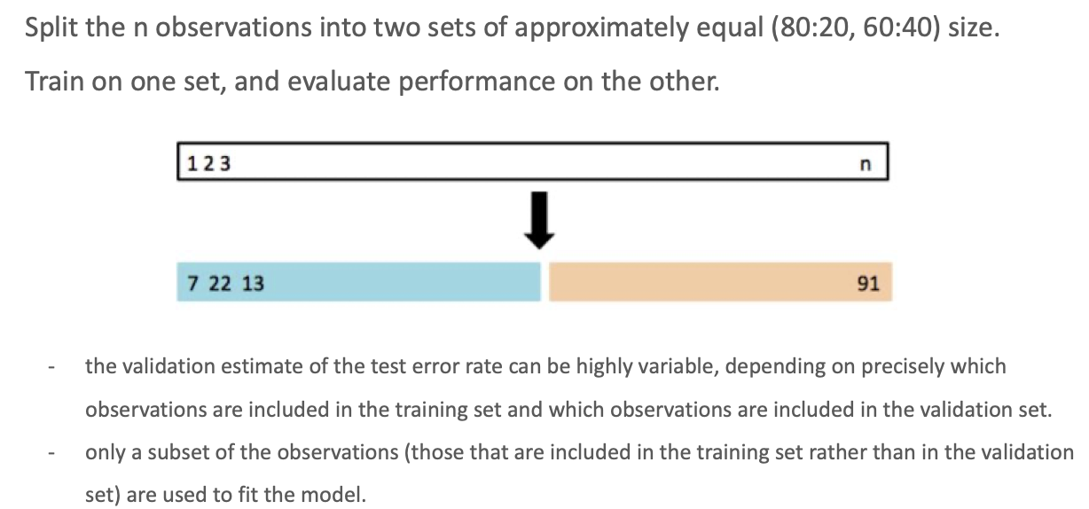

Divide the training data to build the model and evaluate it.

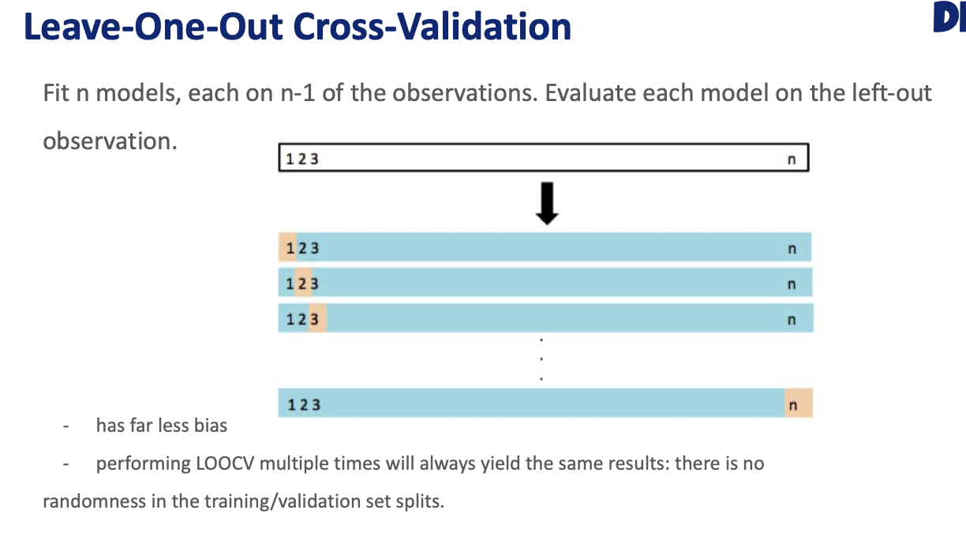

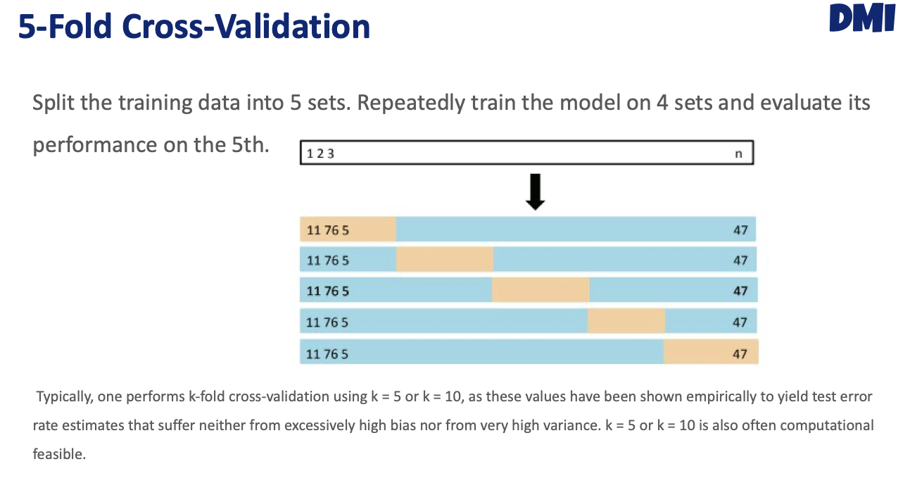

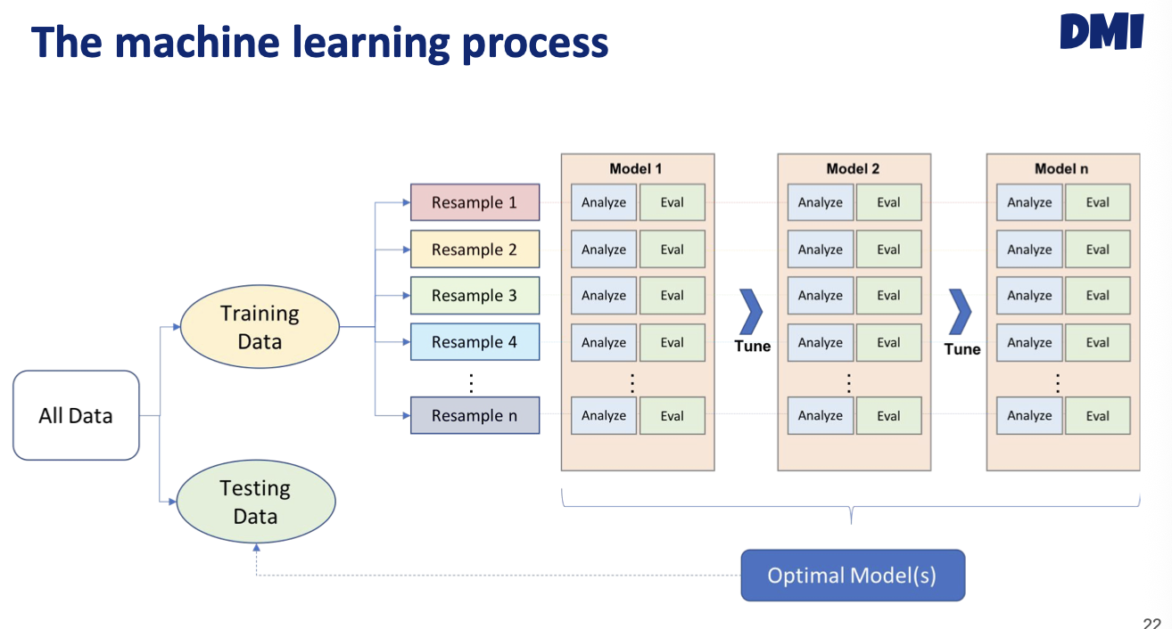

Here we have 4 corss-validation.

## hyperparameter tuning

Create a vector 🡪 KNN, but typicall we might have more than one, so hoe to test different combination for different parameter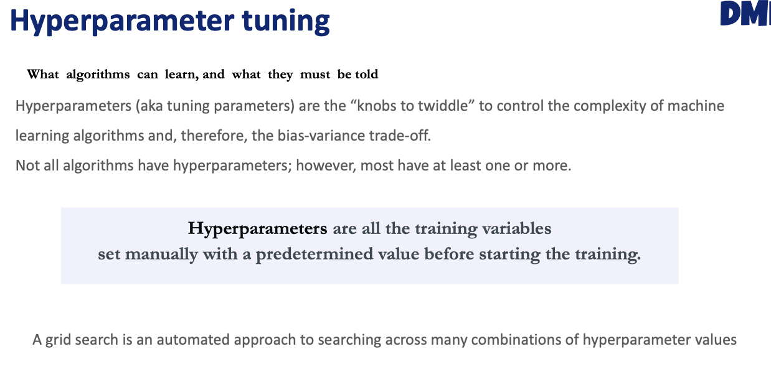

* Babysitting
* Grid search
* Random search

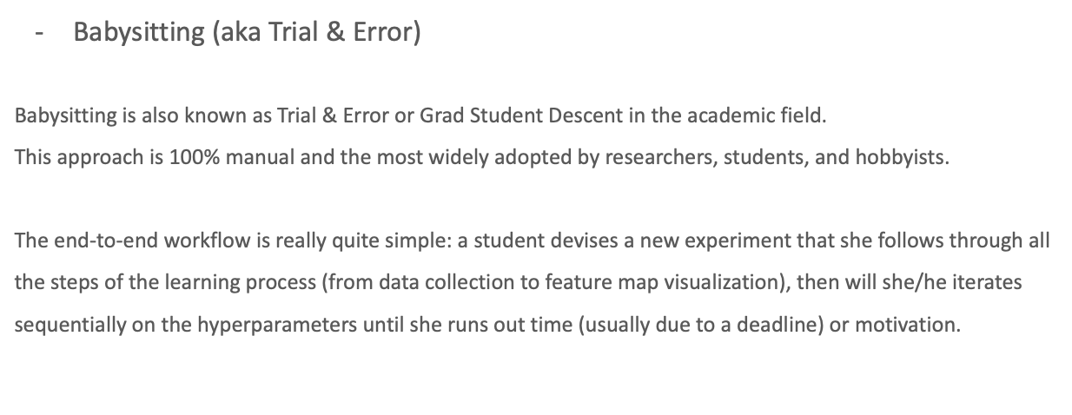

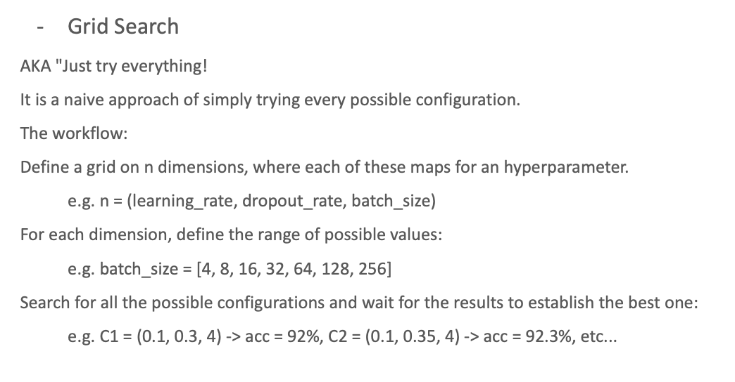

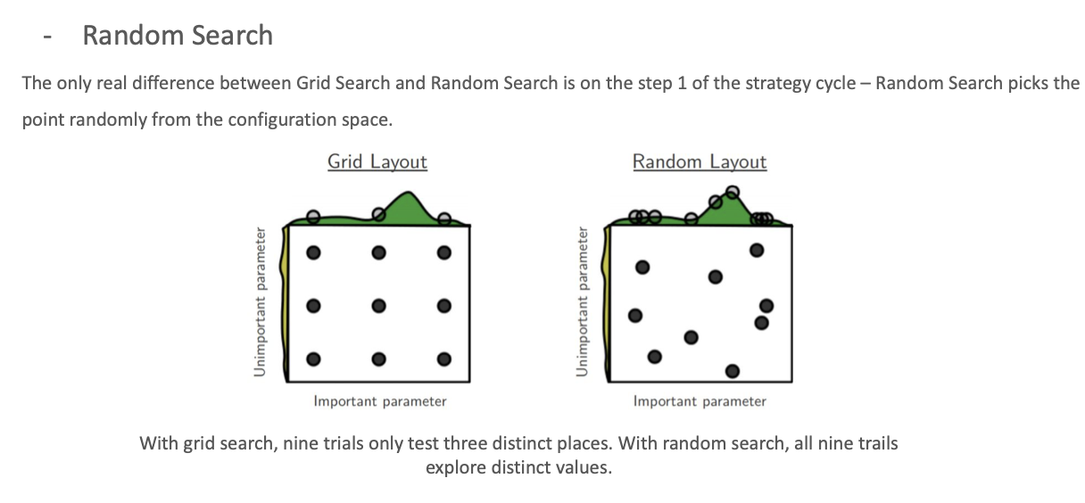

## KNN in R

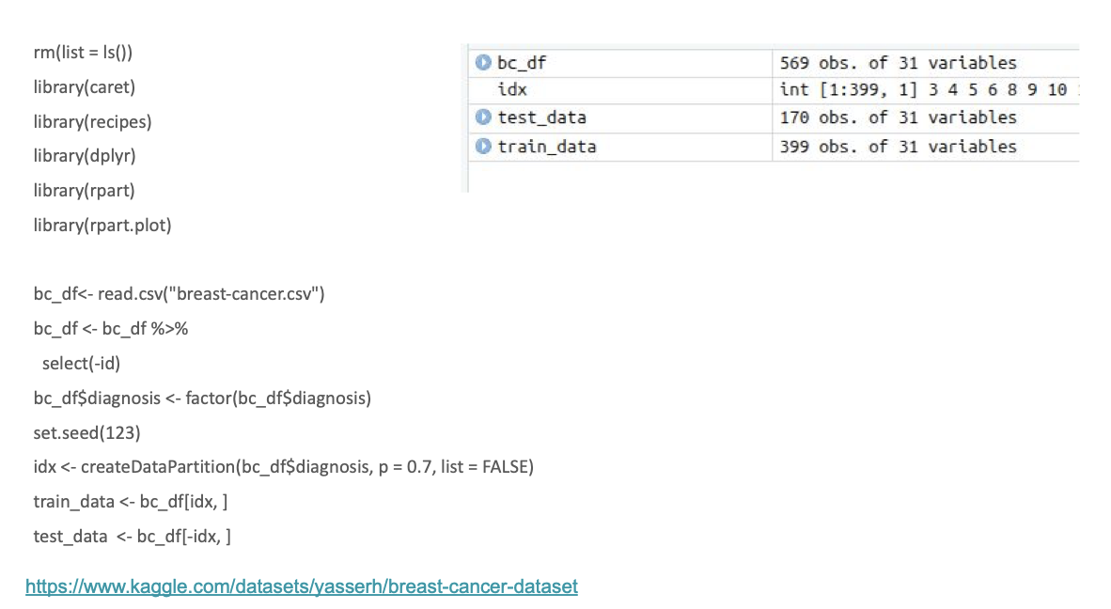

* We are splitting data randomly
* Split the data based on the p value

All 3 methods will start like this the same. Start with 569 patients.

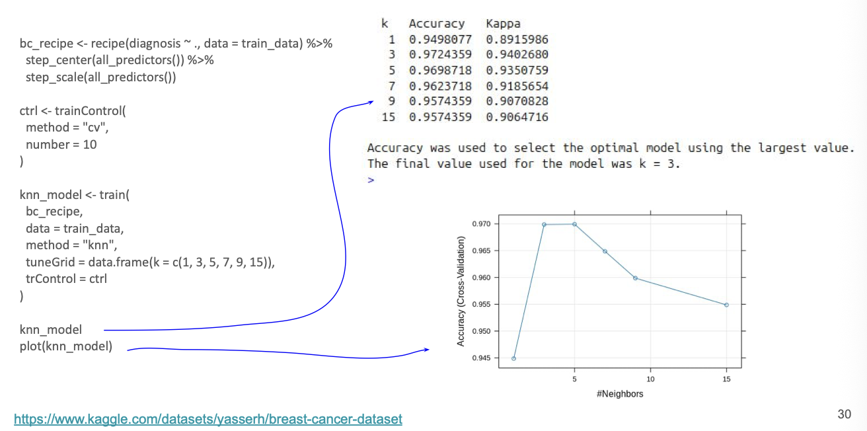



Overfit area

Build 6 models, and explore this combination of nearest neighbour with the crossvalidation approach

First scale and center the data, then crossvalidation

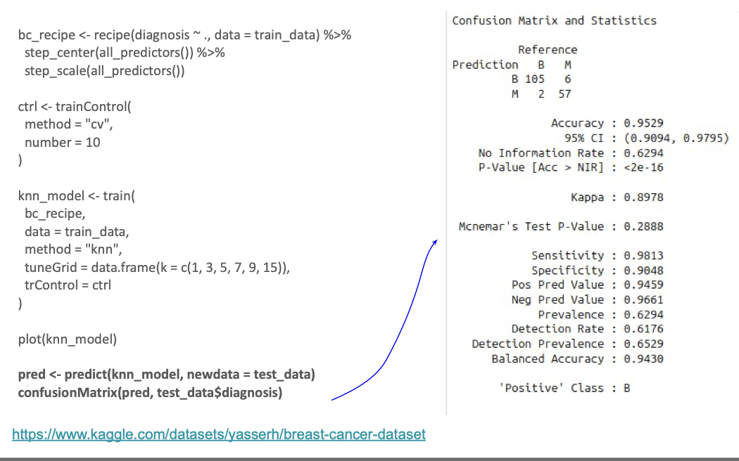



2 predicted malignant and 6 predicted malignant.

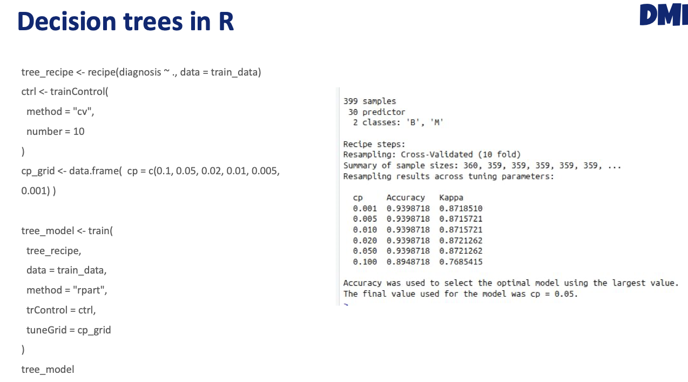

In the decision tree, the hyperparameter is the complexity parameter. Scalining in decision tree does not take into account in decision trees.

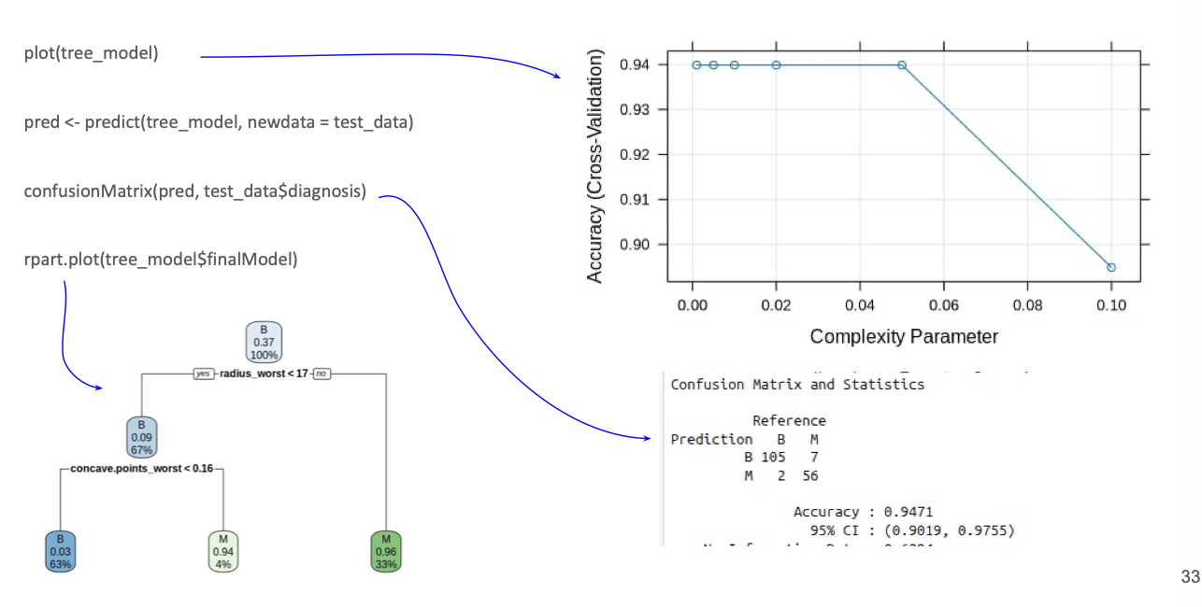

The bootstrap aggregating is more powerfull than the decision tree.

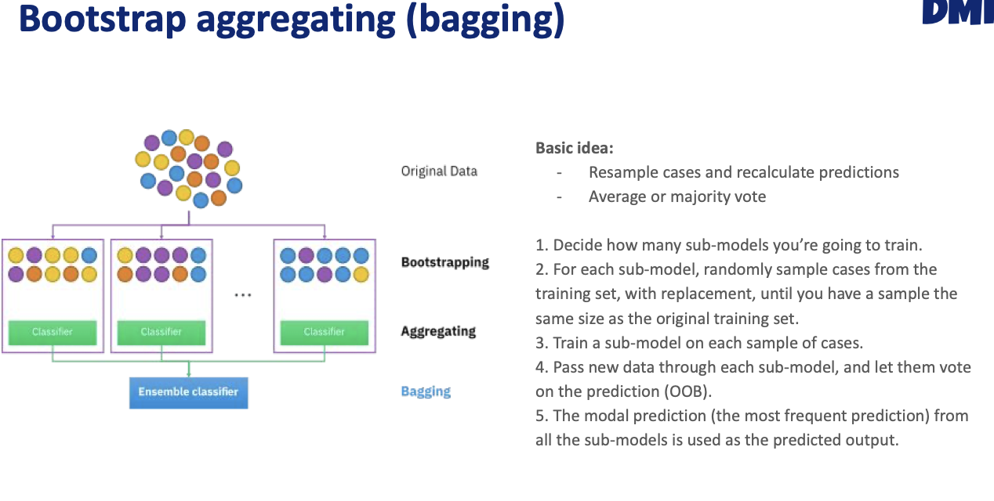

Build many trees with the training data, but not with the whole training data. We are going tot ake the original training data with replacement.

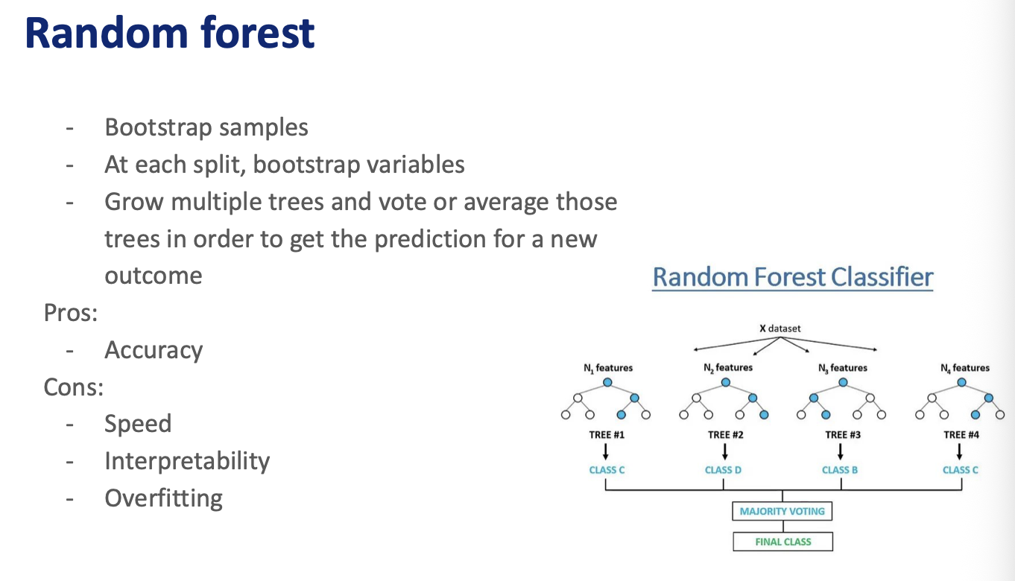



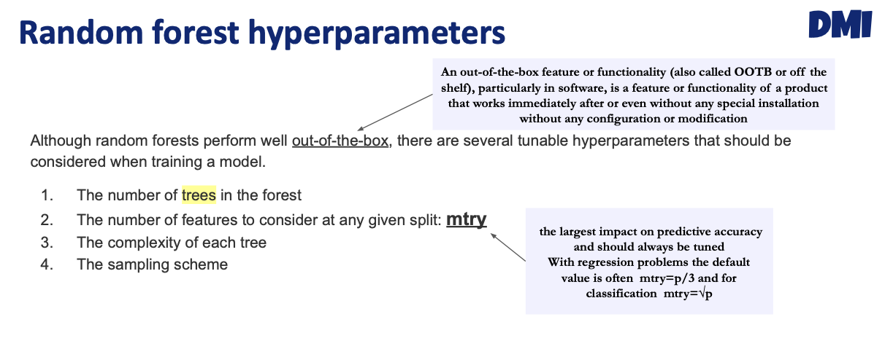

Need beforehand how many features you will be using.

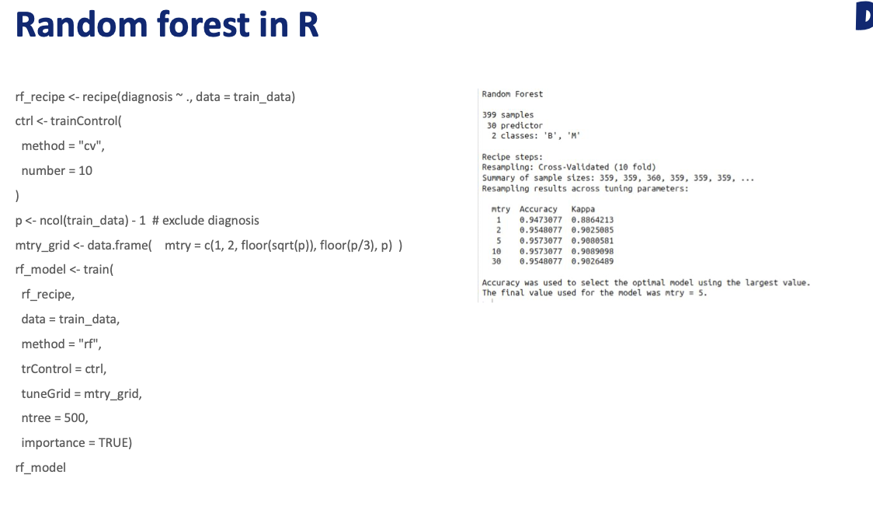

Remove the label of the data

# Introduction To Agentic AI

Build an AI agent with LangChain.

**Langchain** is a framework that allows you to build powerful applications powered by large language models such as OpenAI, Gemini, Anthropic, etc. It helps you to create agents and connect them with tools which the model will use to retrieve data for its response.

## What is an AI agent

Software systems capable to complete tasks or pursue goals. 5 main features of AI agent:

* Agency: autonomously perform actions to interact with and modify the environment
* Reasoning and planning: able to analyze the goal, think and plan, for complex tasks and decompose them into small tasks choosing the best course of action.
* Adaptability and resilience: they can dynamically adjust their behavior to deal with the circumstantial specificities of the task to carry out and the environment to interact with.
* Learning and self-improvement: continuously learn while iterating over specific tasks, self-refinig knowledge capabilities,
* Collaboration: communicate and coordinate with external actors (agents or humans) towards the achievement of a common goal.

## LLM-based agentic AI

Enable software system to virtually deal with any domain and scenario by allowing interactions mediated by language communication.

### What is a language model?

Is a statistical or ML model trained to coherently predict and generate human-like text. As input provides a sequence, it is not text, it is actually sequence model, and predict the order of them. Sequences can be words, and will predict word by word by appending them, it is an iterative process. This is computationally expensive, and when chat with chatbot, is super computational cost, but there are working on optimize it.

NN works with number, cannot work with text, converts text to number!!!

Convert text input to numbers and then numbers to text again. This is done by divide the text into **toquenization**, divide by words (it will depend on the architecture used) and put them in seq and put them in vectors (numbers) and this series of vector forms a matrix as an input for LM, applying an operating inside the black box. Inside it might be **NN operations**, forming an output matrix. Stores inside this LM are weights to generate the output. The output would predict the next word, identify similar words, expressions or documents, or classify textual contents (train the model). Inside the black box, multiply matrices and normalize.

Apart to choose the right architecture, LM learns the semantic of natural language. The sematic of words (meaning of the word) can be derived by inspecting their context of occurrence in large collections of textual data. By looking a lot of occurrences of this words, might understand the meaning of this vector, and compare mathematically. For instance the height of similar words vector is short.

* Language model is not trained, and by see its occurences, would be trained
* The more words taking into account the surrounded word, the better prediction
* Larger and more variety set of in-context examples of words are usually better modelling text semantics.

A LM can do:

* **Text embedding**: given a text, generate a vector representing the semantic of the text, and see if there are similar or not.
* **Text generation**: provide input text, and generate what comes after, or also answer the specific question as input.

### Transformer architecture

Is the architecture of the NN and is the foundational model. Is one of the most powerful classes of neural LM. Substantially provide some tricks inside to solve two problems:

* RNN and LSTM:
  + Sequential processing, word by word (slow training/inference)
  + Long-range word dependences are difficult to model and exploit to improve predictions
* Convolutional NN:
  + Impractical number of convolutional filers.

What are the pieces of this NN?

* Encoder: is a NN that takes as input the sentence and generates as an output a vector of each sentence and provides this to:
  + Text embedding to provide to the decorder
* DECODER: consider this semantic vector as given a prompt, generates a distribution of probability of next word.
  + Text generation
  + 90% uses this decoder mechanism

The attention mechanisms: neural architecture that enables the LM to learn and model the semantics of words by jointly considering words from extremely large context. Thus, transformers can learn any-distance relationship in sequential data, like the words (or tokens) of text excerpts.

The transformer architecture, gets a text input and in each transformation, considers the semantics of each block of this transformer.

The generative model only uses the decoder part, given a text, predict the word that comes after.

* Model open weights, the number of the trained model can be downloaded from the web sites and run locally, or rent big GPU in amazon and run it in cloud.
* Model via API: send text so some URL and get back the generation.

The size of the LLM is defined by the architecture and the amunt of parameters given.

### Decoder based model

With just the decoder block, it is one way to interact with. Every LLM generates text, and every time generated, LLM does nothing more than considering input text and to predict uses deep learning.

* **Deterministic** decoding: Given a specific input, always generates the same text contents
* **Non-deterministic**: specific input text, generate distinct textual contents every time the Generative LM is invoked.
  + Define a k integer number (like 3) choose randomly one of the top-k most probable.
  + When using the top-k algorithm, we use another side parameter which is called temperature, and is useful to preprocess before interpreting.
    - T < 1: increase the % of more likely words
      * Better for accuracy
    - T > 1: more homogeneity
      * Creativity or brainstoriming, more variety of output
    - T = 1: nothing changes

LLM don’t have memory, they forget everything. In generative LM the textual content of the prompt should include all contextual information needed to drive text generation. This remembers exclusive the information they have learnt during the training.

## Fine-tuning

Train a LM to carry out a specific task, modify all the number inside the black box, to carry on a specific task. Let’s say we want to detect gene-disease relations:

1. Training corpus
2. Fine tune -🡪 modify the weights (the numbers)
3. The LM will be able to take as input one of these sentences and see the relationships results.

By scaling the LLM.

The corpus model, the prompt learns the initial question. LLM acquire deeper layers of language comprehension and generation, far beyond simple next-word predictions.

## Improve LLM?

* Scaling the size of large language models (big model, the big the matrix inside, better)
  + But training a bigger model, cost a lot (in terms of computational resources)
* Improved model architecture (how to train faster, the operations inside the matrix)
* Training data selection (make it cleaner the textual data that the LM learn)
* Training/fine-tuning
* Inference-time scaling: instead of training, if I improve the model that generates the results, for instance, if I ask something to generative LM 20 times, I use more resources of inference time, but improve the quality. Not investing in trainig but more resources on computing generation.

## how this decoder mathematicaly learn?

What is the training of LM? Process of modify all this numbers inside the matrix, in order to learn the semantic of the input.

1. Pre-training: when the model learns the overall syntax
2. Supervised fine tunning: make the model learn a specific instruction (specified in the prompt)
3. Alignment: align the model with the user intent

### pretrianing

Learns the overall semantic by means of unsupervised training over huge collections of textual data. Is very computational expensive.

The model learns patterns from unlabeled data (raw text, don’t tell specific features or text).

We first have a nontrained model and what gets the input, initialize the numbers inside and generate tokenization of the input words. To learn from human language, it takes corpus and sentence by sentence form it, modify the weight of the LM to make it more likely the order of the words. At the end the model is trained. This is the most expensive STEP!!

Once the model is trained, a sample of curated text modifies a bit more the number of the weights to fine-tune the LM.

After you have trained the model in function of the instructions, align the model with user intent. In the alignment, the LLM is trained to follow specific preferences, you are able to make more likely the preference of the response. In the reinforcement learning, the user rates the quality of the answer, once this dataset of preference is done, start another train reward-model, and start the cycle again, the prompt is provided and if the output aligns with the dataset.

# Core capabilities of AI agents

Reasoning, tool use, memory and collaboration. assessing the performance of AI agents.

## Reasoning

A Generative Language Model is referred to as reasoning model when:

* The model includes a “thinking” process as part of the responses it generates
* The model excels at performing tasks that require complex reasoning by:
  + Decomposing complex problems into smaller solvable parts
  + Criticizing its own (partial) solutions
  + Exploring distinct alternative solutions

The output is called “token”. So, when should we rely on the reasoning abilities of GLMs?

* Problems that involve logical reasoning, either deductive or inductive like mathematical problems
* Multiple alternatives should be considered and compared to take a decision
* Multi-step reasoning approaches

How to enable and boost reasoning capabilities of GLMs?

1. Make a LLM reason to **train them their internal weights** to enforce their reasoning capabilities. I generate an alignment dataset (question + answers) and obtain a reward ( a number) which will update the LLM weights to generate text, to favor the answer.
2. **Reinforcement learning** is the key technique exploited to teach GLMs to reason. Rely on rewards that can be automatically verified without running a dedicated preference scoring model. (Mathematical correctness, code execution, formatting rewards, compliance with regulations). Compare the obtained value with the expected one to generate a reward.
   1. Reduce computational cost
   2. Improve effectiveness and stability

After pretraining is possible to follow instructions after fine tuning. Supervised fine tuning has been widely exploited to teach models to reason too, especially with small models by relying on reasoning traces obtained by powerful models. So *reinforcement learning is the key technique exploited to teach GLMs to reason*.

By adjusting its internal wiehgt by reinforment data.

### Boost reasoning

Making more complex prompt, difficulties of the questions 🡪 enable answering capabilities.

There are several strategies:

* **Chain-of-thoughts:** provide a chain of thought demonstrations as exemplars in prompting
* **Tree-of-thoughts:** Self-evaluate progress through intermediate thoughts to solve a problem, systematically navigating the reasoning paths.
  + Foster exploration of distinct reasoning paths by repeatedly reconsidering the available information
  + Evaluate the distinct stages of reasoning to understand which to keep exploring, and which not.
* **Graph-of-thoughts:**
* **Least-to-most**

To verify of the exactness of a specific answer or explanation:

* **Self-consistency:** Sample distinct answers and choose the most frequent/average one.
* **Self-verification:** Verify the explanations generated by Chain-of-thoughts prompting by answering questions-known-answer pairs derived from such explanations.

Reflection or and correction of a specific answer or explanation:

* **Self-refinement:** Build task-specific prompts to ask for feedback on a generated answer, then ask to improve that text generation by relying on such feedback.

All this strategy to prompt a LLM to improve its quality:

* Need to carefully craft the prompt to the specific task, under consideration
* Better working with medium/large size LLMs
* Computational cost of bigger/multiple interactions with LLMs

In order to enforce better reasoning 🡪 verifier (more or les the same as the reward model), have a question and answers and test whether the answer is valid for the question or not. Evaluates the correct/quality of the text generated by a GLM.

Another possibility is dynamically assign maximum value of thinking. All the thinking model, when we ask CHATGPT5 we obtain an answer. Another parameter is the maximum token generated. For reasoning model they suggest that we provide at least 25.000 tokens for reasoning and outputs when I start experimenting with these models.

The reasoning_effort parameter when reduced effort can result in faster responses and fewer tokens used on reasoning in response.

## Tool use

Agents rely on the ability of the GLMs to interact with and thus leverage external systems to perform tasks, beyond their inherent text generator capabilities.

Initial prompt (tools description like get_ip_location) 🡪 GLM 🡪 generated text (software please execute this function with this empty location) 🡪 the agent run this function and retrieves the answer 🡪 follow-up prompt 🡪 GLMs 🡪 generated text (saying that the IP address is somewhere else)

Possible to automate a model for a website by specifies the ≠ tools to use. GLMS specify data formats useful to describe usermanaged tools. Describe the user-managed tools as methods available for the model to call, by specifying:

* Name
* Descriotion
* Parameters (JSON shcema)

But when too many tools are provided, the LLM gets confused because there are too many choices and consequently difficult to understand the semantic of each tool. So, the best practices for tool selection an usage:

* Optimize tool descriptions to increase both their clarity and conciseness
* Enable prompt caching to reduce the cost of processing tool descriptions
* Rely on dynamic tool selection approaches, based on RAG or sub-agent dedicated to tool selection

How a GLMs is trained to use this tools? In order to do this, should be able to understand the input and run the specific tool. In supervised-fine tunning (question and expected instruction, and train he model with the expected instruction to obtain the expected answer), uses a set of question that needs to be answers with specific tools.

### Summary of tool expoiltation

* Timing for tool invocation: ability to decompose a complex problem into simpler steps that can be solved by a specific tool.
* Selection the right tool
* Understand of tools parameter: providing the expected types and number of parameters
* Robustness of reasoning and back-tracking: invalidate or recompute the results of a specific tool in case of errors, wrong semantics
* Tool usage efficiency: properly balance the execution time, efficiency and cost of tool usage

## Core capabilities of AI agentic: reasoning, tool use, memroy and collaboration

Every time you ask something we should provide the input of the LM. This does not remember internally. Agent memory enables AI-systems to remember information concerning:

* Past user interactions
* User preferences
* Information useful to contextualize or derive specific tasks they are performing like instructions, procedural constraint or domain-specific knowledge

The initial interaction with the user, the software around the GLM will store the important labels, and when the model is already prompted, this stored information for the specific user, will be pre-appended to the actual question.

We have seen that GLM has a big context size (maximum prompt text lengh = num of tokens):

* Gemini: 1M
* OpenAI: 200K
* DeepSeek: 128K

There are risk to include in context huge amounts of irrelevant information, decreasing thematic continuity of conversation. Long prompts often make the retrieval and usage of past information less effective, increased cost and less interactive (require more time for the LM to think) and also eventually to exceed the maximum prompt text length.

In order to select dynamically or filtered info that should be provided as a context when a user ask a question:

* Circumstantial memory: remember the history of recent interactions, usually happening in the context of a specific session
* Episodic memory: to remember specific, relevant past interactions, including their context and the actions taken
* Semantic memory: remember general knowledge, facts, concepts, rules about the world of user profiles and preferences
* Procedural memory: remember general rules and procedures regulating the overall flow of interactions

When interact with an agent, to store memory in plain text (appending) or use a system called RAG (store the pool of interaction, embeddings of information to remember stored in vector database) or graph of relevant entities and relation extracted from information to remember.

Mem0 is a python library that can be attached to a python framework,

# Python-lab: building an AI agent (practical session of building an agent)

LangCahin is a python library framework that simplify the construction building the AI agent.

# Nonparametric regression model and linear & mixed-effects models

# My notes!!!

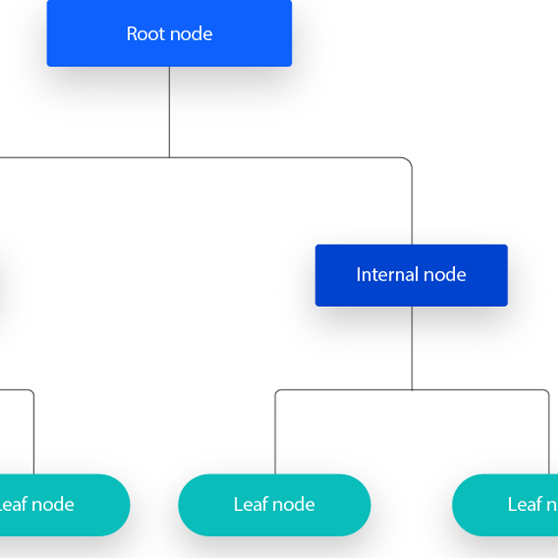The decision tree starts with a root node, which does not have any incoming branches. The outgoing branches from the root node are known as decision nodes. The leaf nodes represent all the possible outcomes within the dataset.

As the tree grows in size, it results in too little data falling within a given subtree, it is known as *data fragmentation = overfitting*.

In machine learning, **overfitting** occurs when a model fits too closely or even exactly to its training data, such that it can’t make accurate predictions or conclusions from any data other than the training data.

As a result, decision trees have preference for smaller trees, decision trees should add complexity only if necessary. To reduce complexity and prevent overfitting, pruning is usually employed. This removes branches that split on features with low importance. The model’s fit can the be evaluated through the process of cross-validation. Pre-pruning halts tree growth when there is insufficient data while post-pruning removes subtrees with inadequate data after tree construction.

Another way that decision trees can maintain their accuracy is by forming an ensemble via a random forest algorithm, this classifier predicts more accurate results, particularly when the individual trees are uncorrelated with each other.

**Entropy** measures the impurity of the sample values:

* If all samples in data set, S, belong to one class 🡪 S = 0
* If half of the samples are classified as one class and the other half are in another class 🡪 S = 1

The attribute with the smallest amount of entropy should be used. **Information gain** represents the ≠ in entropy before and after a split on a given attribute. The attribute with the highest information gain, will produce the best split (best job at classifying training data according to its target classification).

**Gini impurity** is the probability of incorrectly classifying random data point in the dataset if it were labeled based on the class distribution of the dataset.

Predict the correct label for input data.

At the **end of the model training process**, the model’s performance is evaluated by using test data. After the model performs consistently well, it’s introduced to unseen real-world data. The trained neural networks apply what they learned during training to make successful predictions with new data.

A **classification model** is a type of machine learning model that sorts data points into predefined groups called classes. Classifiers learn class characteristics from input data, then learn to assign possible classes to new unseen data according to those learned characteristics. AI models use **classification algorithms** to process input datasets against a specified classifier that sets the criteria for how the data should be sorted. They follow the same general two-step data classification process:

* Learning
  + Classification has traditionally been a type of supervised machine learning, which means it uses labeled data to train models. In supervised learning, each data point in the training data contains input variables (also known as independent variables or features), and an output variable, or label. The model’s job is to understand the relationship between features and class labels and apply those criteria to future datasets. The model considers each data point as a tuple (an ordered numerical sequence: x1, x2, x3, …, xn. And each value of the tuple is a feature in the data. By mapping training data with this equations, a model learns which features are associated with each class label.
  + The purpose of training is to minimize errors during predictive modeling. Gradient descent algorithms train models by minimizing the gap between predicted and actual results model can alter be fine-tuned with more training to perform more specific tasks.
  + Unsupervised learning methods enable models to discover patterns in unlabeled data by themselves.
* Classification
  + Users deploy the model on a test set of new data. Previously unused data is used to evaluate model performance to avoid overfitting: when a model learns too heavily on its training data and becomes unable to make accurate predictions in the real world.
  + The model uses its learned predicted function to classify new data across distinct classes according to each sample’s features. Users then evaluate model accuracy according to the number of correctly predicted test data samples.
  + Classification:
    - Binary classification (sorts data into two exclusive categories)
    - Multiclass classification (sorts data into more than two exclusive categories)
    - Multilabel classification (sorts data into nonexclusive categories)
    - Imbalanced (unequal distribution of data points across categories)
  + Types of classification algorithms:
    - **Logistic regression**
    - **Decision tree** 🡪 used for both classification and regression
    - **Random forest** 🡪 ensemble technique combining the output of multiple trees into a single result. The resulting “forest” improves prediction accuracy over that of a single tree while countering overfitting. Used for both classification and regression.
      * Create multiple decision rees for each task, aggregate the rpediciton of all the trees, then choose the most popular answer as the definitve results.
    - **Support vector machine (SVM)** 🡪 plots data itno a multidimensional space, with the number of dimensions corresponding to the number of features in the data. The algorithm’s goal is to discover the optimal line that best divides the data points into categories.
    - **KNNs** 🡪 map data points onto a multidimensional space. It then groups those data points with similar feature values into separate groups, or classes. To classify new data samples, the classifier looks at the *k*number of points nearest to the new data, counts the members of each class comprising the neighboring subset, and returns that proportion as the class estimate for the new data point. KNN models are lazy learners, which don’t immediately build a model from training data, but instead refer to training data and compare new data to it. In high dimensional data spaces, it is computationally expensive to find a data point’s exact neighbors, so for that dimensionality reduction and ANN are two solutions to this issue.
    - **Naïve Bayes**
    - **Ensemble methods** 🡪 Ensemble methods and machine learning techniques combine multiple smaller models into a single classifier for improved results. Deep ensemble methods bring multiple deep learning models together to create even more powerful ensemble classifiers. Ensembles with deep learners can handle complex multilabel classification tasks.
      * Refers to a group of base learners, or models, which work collectively to achieve a better final prediction. A single model, also known as a base or weak learner, may not perform well individually due to high variance or high bias. However, when weak learners are aggregated, they can form a strong learner, as their combination reduces bias or variance, yielding better model performance. Each model learns sequentially. This means that a series of models are constructed and with each new model iteration, the weights of the misclassified data in the previous model are increased. This redistribution of weights helps the algorithm identify the parameters that it needs to focus on to improve its performance.
  + Some of the most popular evaluation metrics are:
    - Accuracy
    - Precision

All measure the accuracy with which learners, or classifiers, accurately predict model classes

* + - Recall
      * True + rates
      * Shows how often a model detects members of the target class in the dataset
    - F1 score
      * Combines precision and recall
    - Confusion matrix
      * Shows predicted vs real values
    - ROC curve
      * Depicts the proportion of true + to true -